

Capstone Project Phase B – 61999

Project code:24-1-D-18

Realtorsphere - Software for real estate agents

Marina Shteinfer - 323305458

Marina.Shteinfer@e.braude.ac.il

Hanna Kruchenetzky - 207409764

hanna.kruchenetzky@e.braude.ac.il

Advisor:

Zeev Barzily

[zbarzily@braude.ac.il](mailto:zbarzily@braude.ac.il)

**Table of Contents:**

1. **Abstract ………………………………..…. 3**
2. **Introduction …………………………….…3**

**2.1. The problem we want to solve……….…..3**

**2.2. Stakeholders………………………………4**

1. **Related Work………………………………4**
2. **Solution………………………………….….6**
3. **Development Process………………………7**

**5.1. Tools and methods we have chosen for the development ……8**

1. **Diagrams……………………………………11**
2. **Challenges…………………………………..12**
3. **Results and conclusions…………………….12**
4. **Maintenance Guide ………………………..15**
5. **Tests…………………………………………28**
6. **User Guid…………………………………..39**
7. **Referance………………………………….65**
8. **Abstract:**

"RealtorSphere" is a customer relationship management (CRM) system designed to assist real estate agents in managing efficiently properties, clients, and property owners. This software simplifies workflows by offering features such as editing information about clients, owners, and properties, tracking price suggestions, saving events and tasks, helping realtors improve customer engagement, streamlining tasks, and helping find suitable properties for clients.

The backend utilizes Firebase, a cloud-hosted NoSQL database that ensures real-time data synchronization and accessibility, and Firebase storage for file saving. PyCharm serves as the primary development environment, while GitHub is used for version control and team collaboration. The backend is powered by Python, using Flask for routing, while React JS handles the frontend development.

RealtorSphere also incorporates technologies like smtplib to enable email functionalities such as password resets and client communications. The system is designed to address inefficiencies in the real estate industry by minimizing paperwork and automating key processes, making it easier for agents to manage their business from a single platform. Through a combination of cutting-edge technologies and user-centric design, RealtorSphere aims to modernize the real estate industry.

1. **Introduction:** The problem we want to solve:  
    The traditional methods employed in the real estate industry are often marked by exhausting paperwork, disparate data sources, and time-consuming processes that need to be updated in the evolving technological landscape. Real estate businesses suffer heavily from mistakes that can be avoided through effective customer engagement and [data management systems](https://www.softwaresuggest.com/data-management-software).  
    The demands of the real estate market are ever-growing, so the crucial role of the agents in this field in facilitating property transactions demands a streamlined and technologically adept approach. Recognizing the urgent need for progressive solutions, this software program aims to cope with the pressing challenges faced by real estate agents, providing them with an effective toolset to enhance their workflow, improve interactions with clients, and in the long run- elevate their effectiveness in a highly competitive industry.  
    With this software, we aim to bridge the gap between outdated practices and modern technological capabilities and provide a comprehensive solution to the specific needs of real estate professionals.

Who are the stakeholders & how will the software benefit them?

The software will be beneficial, of course, for real estate agents. RealtorShpere purpose is to improve property management: it will streamline property management tasks, allowing realtors to organize, update, and track asset details easily. Other goals are to improve client matching by identifying properties that align with client preferences, to edit properties, clients, and owners’ data in the program for maximum accuracy, to increase customer satisfaction, and to make the process of the transaction easier.

The software will also help with task management- it will aid in scheduling appointments, managing work diaries, and creating reports to increase productivity.

Stakeholders can also be property owners. The software will be beneficial for them because it streamlines communication. The software can ease the communication between real estate agents, property owners, and clients during negotiations, ensuring a smoother selling or renting process.

Property buyers can also benefit from this software. It gives property recommendations. Buyers receive personalized asset suggestions based on their preferences, enhancing their experience and satisfaction. It also provides a convenient communication way for realtors to send emails to their clients.

Detailed reports and analytics provided by the software will be useful to realtors and property owners for data-driven decision-making. Real estate agents will be able to make informed decisions for the growth and optimization of their businesses.

**3. Related Work:**

For this project, we investigated what kinds of programs already exist in the real estate field, world wild, and specifically in Israel. We wanted to know what they are offering and also what they are lacking. This is what we have found:

HubSpot is a comprehensive customer relationship management (CRM) platform that offers a suite of marketing, sales, customer service, and content management tools. It allows businesses to manage their interactions with customers, automate various processes, track leads, analyze data, and create personalized marketing campaigns.

Monday.com is a versatile work operating system (Work OS) that offers various features and templates for managing projects, tasks, and workflows across different teams and departments within an organization. Its features include customizable boards, timelines, automation, integrations, and collaboration tools that can be tailored to fit sales processes and CRM needs. Users can create visual pipelines to track leads, deals, and customer interactions, set up automated workflows for repetitive tasks, integrate with other software tools like email clients and communication platforms, and collaborate with team members in real-time.

Pipedrive is a customer relationship management (CRM) software designed to help businesses manage their sales pipelines effectively. It provides a user-friendly interface and customizable features to streamline the sales process and track deals from initial contact to closure. With this program, users can create visual pipelines to track deals and sales opportunities at different stages of the sales process. It also allows users to store and organize contact information for leads, prospects, and customers in a centralized database. In addition, users can schedule tasks, set reminders, and log activities related to sales interactions to ensure timely follow-ups and engagement with leads. Other qualities are Email Integration with Gmail and Outlook, reporting, and Analytics tools to track sales performance and customize pipelines, fields, and workflows to align with their specific sales processes and requirements.

Salesforce is a cloud-based CRM platform that assists businesses in managing sales, marketing, and customer service activities by providing tools for storing and organizing customer information. It offers automation features to streamline sales processes and track sales opportunities through various pipeline stages. Salesforce also includes marketing automation tools, customer service support features, analytics, reporting capabilities, and customization options for integrating with third-party applications.

Capsule is a cloud-based CRM software tailored for small and medium-sized businesses (SMBs) to manage contacts, sales pipelines, and customer interactions efficiently. Its key features encompass contact management, customizable sales pipelines, email integration, task and calendar management, reporting and analytics, and customization options to align with specific business needs. Capsule offers a user-friendly interface and essential functionalities to streamline sales processes and enhance customer relationships.  
  
 In Israel, the current solutions are Homely, nadlanOne, and Bmby.

BMBY is a real estate agent system that streamlines various tasks such as managing client portfolios, matching properties to customer requirements, facilitating communication via SMS and email, generating and organizing reports on sales and market trends, marketing properties on websites and real estate boards, integrating with MLS systems, and providing google map views of properties.

Homely offers professional services and products tailored to real estate agencies, primarily focusing on their website as a platform to promote agency publications. It includes internet brokerage software utilizing Microsoft Silverlight for remote work, local brokerage software by Midan Software for customizable interfaces and automatic backups, and a mobile application for managing office tasks and accessing real estate information worldwide.

NadlanOne is a real estate program with a user-friendly interface and a mobile agent for property notifications. It has a comprehensive database of apartments and mediators' publications, integrates with MLS in the country, and offers features like digital signature and Comparative Market Analysis reports. Additionally, it enables the creation of unlimited landing pages for property marketing and operates seamlessly with property IDs, ensuring continuous support for agents 24/7.

Furthermore, we surveyed realtors for a better understanding of these programs and what they lack. We asked realtors the following questions:  
 * What software do you use today?  
 * Why did you choose this software?  
 * How would you better it, or which features would you add to it?  
 * What are the basic features every real estate software should have?  
 * Anything else you’d like to add?  
 Based on the answers we’ve collected we came to these conclusions about the Israeli real estate softwares:

- Some CRMs can be better. It should be easier to edit the client’s details.

- There is a need for documentation of meetings.

- Most software is available on multiple devices and it increases productivity.

- The software needs to be easy to understand and use, to have an archive of properties, and to collect properties from the web.

Thanks to this information and other research that we have done in phase A we cloud develop this software.

**4. Our Solution:**

RealtorSphere is a comprehensive web software solution made for real estate agents designed to improve property management, customer interactions, and overall efficiency in the dynamic real estate landscape.  
 Characteristics of the property management side of the software will be:  
 Properties are identified by a unique ID and additional details such as price, size, mode(active, archive), location, pictures, number of floors, and parking options, and if there is air conditioning, bars, balcony or garden, safe room, and storage room, and security measures. Other information can be added in notes if needed.  
 Realtors can upload photos and structural plans.  
 The property types in the software are ordinary apartments, duplex apartments, penthouses, private homes, and "Two-Family" Houses.

The software helps with client management. Property owners are identified by first name, last name, email, phone number, and ID, and clients are identified through their contact details (name, surname, email, ID, and phone) the system will intelligently match properties with client preferences.

Realtors are identified by first and last name, ID, email address, password, phone number, and real estate license number. The realtor can manage and organize assets for rent or sale and by status and customers by owners and clients. The realtor can manage and edit properties, clients, and owners and organize them by type, status, etc.

The realtor will be able to record client details, connect them with relevant properties, schedule appointments, manage a work diary, set goals, receive reminders for daily tasks, and update and mark them as ‘completed’ tasks in the work diary.

Price negotiation and communication can be done through the software. The realtor can update and save price proposals from owners and customers and add notes.  
The software will include an archive for properties moved there by the real estate agent after they’ve been sold or if the owner decides not to sell/rent, with the option to add a reason.

The software will generate detailed reports about the properties- amount of archived properties and active properties throughout the last month, half year, and year, and the reason for archiving, number of interested clients for each property and the average time it takes the realtor to close a deal.

**5. Development Process:**

In the developing process of this software, we first investigated the world of real estate and what real estate programs look like. We searched for existing programs of realtors that are available on the market and also reached out to realtors so that they could explain to us how they work, what they liked about their program, and what they would like to improve. Next, we researched how technology and the real estate field are related to know which technologies are better to use in our project. In addition, we also looked for useful algorithms that may be beneficial to the project. We concluded that a good matching algorithm may help realtors close “deals” more effectively and efficiently. Based on that information we created a requirements list with functional and nonfunctional requirements, so we are able to work according to it and make the software more useful for the realtors. Next, we planned our software, how it would look like, and what the realtor would be able to do with it. We chose our technologies and methodologies for the project, so we were able to develop the software in the best way possible and more efficiently. With this process, we want to create effective and easy-to-use web software for real estate agents in the hope it will make their work more simple and beneficial.

Methods we have chosen for the development:

Web application:

We have chosen a web application for our software mostly for the reason it is very accessible. It does not require from the user any special installation, he will need only a connection to the internet and a browser. Additionally, web applications are responsive and can be accessed from various devices, like: computers, phones, iPads, etc. This way the realtor can work from every place without having a computer nearby. Web applications are also beneficial for development, they can be developed in a short time, can work with several backend code languages, and with a lot of development tools and libraries(Nodejs, bootstrap, tailwind CSS).

Version Control:

GitHub is a widely used tool for version control and collaboration, allowing developers to store, manage, and track their code. In our project, GitHub serves as a cloud-based service that allows multiple developers to work on the same code simultaneously while keeping a record of all changes. This version control system makes it possible to track code alterations that were made over time, roll back to earlier versions if needed, and oversee the project workflow effectively.

Other GitHub features are branching and merging, which allow developers to work on different features or bug fixes without affecting the original project. Each developer can create a branch to work independently, and once their changes are complete and reviewed, GitHub merges them safely back into the main code. This ensures that the project remains complete and allows for seamless collaboration and contribution from all team members. By centralizing the codebase, GitHub can improve team cooperation, code integrity, and overall project management.

Client Server Model:

Client-server is a model of communication between two programs, the client program which asks for a service from a server program. There can be several clients on a single server. The connection between client and server is like this: the client sends a request for data to the server through the network and the server accepts the request, finds the data, processes it, and sends it back to the client. Client-server uses protocols such as DNS, HTTP, HTTPS which are common for web communication. The main advantages of this model are less maintenance and the client, and the server can be changed separately. Since our project is web application it uses Client-Server Model. The client side and Server side are both deployed to Render separately so it will be easier to make changes without redeploying the whole code. In this project, the client side is in ReactJS and the server is in Python.

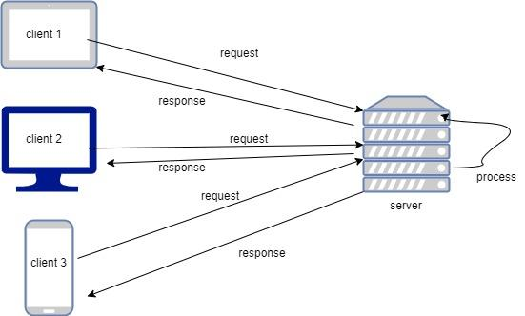

Hybrid Matching Algorithm:

In this project, we have decided to use a matching algorithm to find the most accurate properties for potential clients. The hybrid algorithm includes using:

* Content-based filtering that can find recommendations based on user preferences and item qualities, which means that the algorithm will find properties for a client based on what he prefered.
* Collaborative Filtering can make predictions or suggestions about unknown preferences for user based on the known preferences of a group of users. In our application it can suggest properties for clients based on what other clients with similar prefernce liked.
* Cosine similarity - for Content-Based Filtering. Cosine Similarity is used for comparing how similar two data objects are. It needs to change the data objects to vectors and measures the angle between them: the smaller the angle, the more similar the objects are. If two objects are far apart, they can still be considered similar if their angle is small.

Cosine Similarity is particularly good because it focuses on the direction (angle) between data points rather than their size or distance, making it effective in multi-dimensional data comparisons.

The formula to find the cosine similarity between two vectors is:

(x,y) = x* y/||x|| X ||y||

In our project we use Cosine Similarity to compare how close client preference to property attributes. We compare clients budget with property price, clients rooms and size preference to property measurements and property type with what the client looking for. After this comparison we hope to find him the best matches.

* K-Nearest Neighbors - for Collaborative Filtering. The K-Nearest Neighbors (KNN) algorithm is a simple and widely used machine learning technique. It belongs to supervised learning, where it uses prior data (training data) to classify new data points. KNN works by finding the 'K' closest neighbors to a new data point based on a distance measure.

KNN is non-parametric, meaning it doesn't assume anything about the data distribution, making it flexible for various datasets, including both numerical and categorical data. The class or value of a new data point is determined by the majority vote or average of its nearest neighbors. It's also less sensitive to outliers compared to other algorithms.

In our project we use this algorithm to compare and to find to target client similar clients and to see what their preferred properties are. Based on this information the algorithm can also give properties suggestions to the client.

With the combination of both algorithms we hope to make the finding process for the client much easier and help the owners to sell/rent their properties faster.

Work Methodology:

Agile methodology is a project management method approach that breaks the project into small phases, after each phase is complete the project gets feedback and before the next phase is started the developers make changes and plan the next phase accordingly. This method highlights the collaboration between developers and improvement. The work cycle is planning, executing, and evaluating. The heart of the agile methodology is the collaboration between different teams of the development project and the trust between them. Agile uses feedback mechanisms and constant improvement. The project gets feedback when each part is complete, and thanks to that if there are changes to make it will be easier because the rest of the project is not done yet, so there is no need to redo parts and the next phases can be altered so it will suit the new plan and be less fixed. In our project we used this method, and every few weeks we showed our progress to get feedback and make adjustments according to it.

**6. Diagrams:**

Class Diagram:

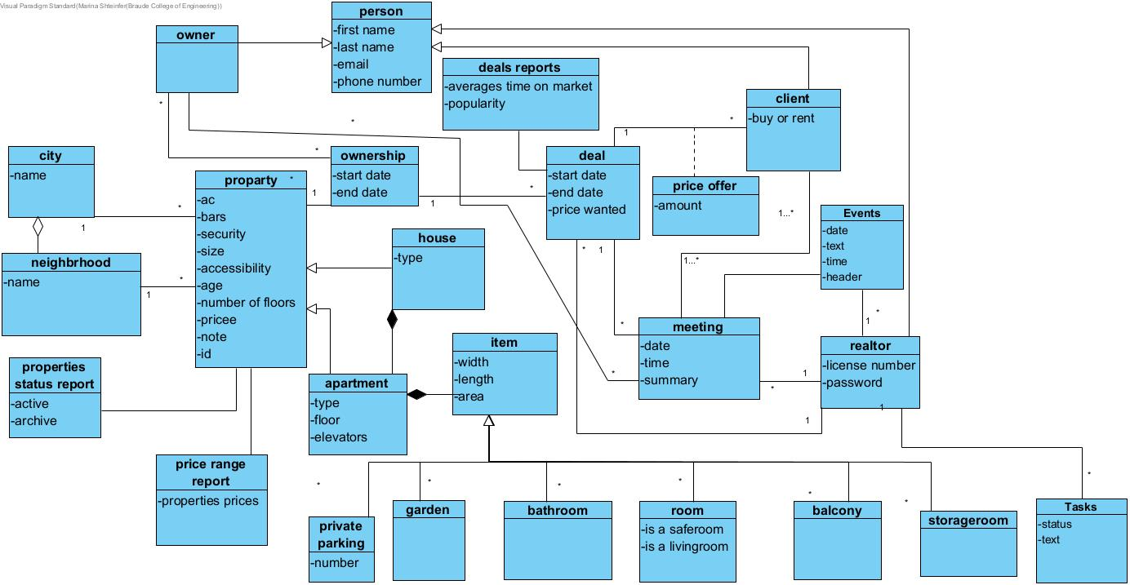

Activity Diagram:

In this diagram described the process of suggsting properties to a new client using the matching algorithm. After adding a new client with his preferance, the realtor can use the matching page to generate the algorithm and find properties based on previous clients and client dameneds. If the algorithm find sutible properties, it can send it to the client to continiue the process.

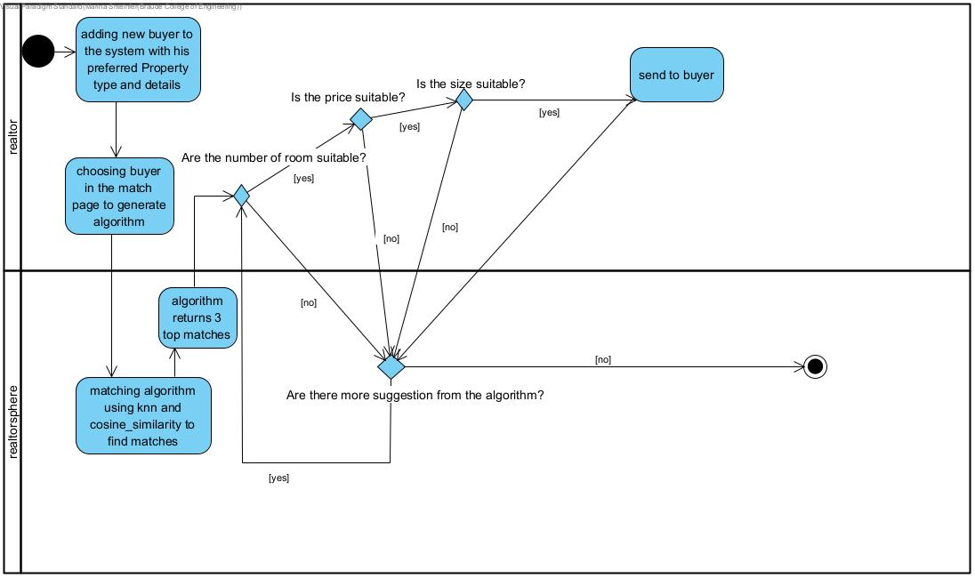

**7. Challenges and solutions:**  
One of the initial challenges we faced was deciding whether to develop the software as a application or a website. After careful consideration, we opted for a website to ensure accessibility from any device a realtor might use. Initially, we began development using HTML; however, we encountered difficulties in creating a responsive and dynamic user interface. Through research, we also found that React is more efficient for creating web pages, as it requires fewer files and offers better component management. Consequently, we transitioned to React, which presented its own challenge, as we had to learn and adapt to this new technology.

Another significant challenge was managing the Firebase private token. The website functioned correctly in a local environment with a private GitHub repository, but after switching the repository to public, security issues arose, causing the website to stop working. To resolve this, we utilized Render for deployment, enabling access to the website via a secure, public link. We addressed the Firebase security issues by creating a copy of the project in a separate private repository, deploying it to Render to be used from the cloud instead of a local environment. The token was removed from the original project and stored securely in a zip file within the repository, which was made public, allowing the website to remain accessible while preserving security.

In addition, we faced challenges with scraping data due to anti-scraping measures on the Yad2 website. Although the scraping did not work, we implemented the algorithm to demonstrate how it would function if the data could be retrieved. Another technical hurdle was the connection to Firebase. Initially, we struggled to connect properly, but we resolved this by switching from Firestore to Firebase’s Realtime Database, which provided the necessary functionality.

Time constraints posed another challenge, as we were managing other courses concurrently. Although we had many ideas for additional features, we had to prioritize and let go of some aspects due to the limited time. However, by working together effectively and dividing tasks, we were able to make the most of our time and deliver a strong project within the given deadline.

**8. Results and conclusions**We successfully developed a website that allows efficient management of clients and property details. Both client and property information are easily editable, and the details are clearly displayed. Additionally, the website facilitates communication with clients through an integrated email system, enabling realtors to send emails directly to clients. A key feature of the system is the matching algorithm, which assists realtors in identifying the best property matches for clients. The system also provides valuable reporting tools, allowing realtors to track metrics such as client interest in properties, the average time it takes to close a deal, and the average time properties remain on the market.

Moreover, the website offers features to manage meetings, record price offers, monitor price negotiations, maintain a calendar with notifications for upcoming events, and manage a to-do list. The search and filtering functionalities make it easy to locate specific properties or clients.

One of our primary goals was to ensure the web application was user-friendly and intuitive. The interface is straightforward, and the website is entirely in Hebrew to cater to realtors in Israel.

Throughout the project, we faced several challenges. We had to acquire new knowledge by researching online resources and consulting realtors to better understand their needs. These conversations clarified the requirements of a real estate management system. Additionally, we had to familiarize ourselves with the technologies that best suited our project’s requirements.

Overall, we gained substantial experience during the system's development. We worked collaboratively using Git and Firebase, and we learned to use new languages and technologies, including React, JavaScript, and Render. These tools were effectively implemented into our project.

In retrospect, one aspect we would change is how we allocated time to the project. While we worked on it nearly every day, dedicating a specific day each week, in addition to the rest of the week's work, solely to the project could have allowed us to achieve even more of our goals.  
  
  
**9. Accomplishments**:  
  
We successfully achieved the majority of the functions we set out to implement in our website. Our primary goal was to develop a functional, user-friendly, and easily editable CRM system, which we accomplished. Additionally, we aimed to display properties and their details in an organized and accessible manner, which was also successfully realized.

A key accomplishment was the successful implementation of the matching algorithm, which allows realtors to find suitable property matches for clients, as well as the ability to track price negotiations through the 'Deals' page. Furthermore, we met our objective of enabling the system to generate detailed reports, providing realtors with valuable insights into their property listings and client interactions.

While we initially planned to extend the CRM system to include features for professionals such as lawyers and appraisers, as well as a profile editing page for realtors to manage their personal details, time constraints led us to prioritize the completion and refinement of the core functionalities. We chose to focus on optimizing the existing features, as they were deemed more critical to the system's overall performance and user experience.

**Maintenance guide for "RealtorSphere":**

Working environments:

**FireBase RealTime DataBase:**

It is the DataBase of our project and it stores the information of our software. It is a computing and development tool developed by Google and a cloud-hosted DB. Firebase uses a NoSQL database and stores its data as JSON files. The main advantages of this database are that it stores and synchronizes data in real-time to each connected client and it is easier to maintain because it is online and easy to access, doesn’t require installing any additional software and it can be shared with several developers on the same project.

Database Architecture:

‘Person’: There are 4 types of persons: realtors, the main user of the system, owners that sell or rent properties, clients that want to buy or rent property, and professionals like lawyers to consult with them. They are described like this:

- "id": To save the owners.

"FirstName":

"LastName":

"Phone"

"Type":

"Owner":

“Realtor”: The realtor that the owner works with.

"Email":

- "id": To save realtors.

"FirstName":

"LastName":

"Phone":

"Type":

"Realtor":

"license":

"password":

"email":

-"id": To save clients.

"FirstName":

"LastName":

"Phone":

"Type":

"Client":

"PropertiesList": List of properties that the client found suitable for himself and wants to continue the renting/ buying process with them. It keeps them as an array.

"budget":

"buyORrent":

"maxRooms":

"maxSize":

"minRooms":

"minSize":

“Realtor”: The realtor that the client works with.

“Searchcity”: keep an array of cities where the client is looking for property.

"email":

‘Property’: Saves information about all the properties in the pro

"id":   
 “Price”

"ac":

"Accessibility":  
 “archiveReason”: If the property is archived

"age":

"bars":

"city":

"house":

"neighborhood":

"notes":

"number_of_floors": The number of floors inside the property.

"pictures":

"file1": "" The pictures are saved in Firebase storage, and in DB saved a path for the picture  
 “realtor”

"security":

"size":

"status":

"street":

"type":

"apartment":

"apNum":

"elevator":

"floor": If the property is an apartment, then on which floor it is. inside the building.

"item:":

"Pparking":

"number":

"bathroomsNum":

"rooms": Here are saved details about each room in the property. We save information about the room size and type of room: Bedroom Living Room, Bathroom, Balcony, Garden, Safe room, and Storage

0:

"length":

"roomType":

"width":

"type": The type of the property is also saved:

Apartment, Duplex Apartment, Private Home, Two-Family and House Penthouse

‘Ownership’:

“ id”: The same id as the property from ‘Property’

"PersonID": The ID of the owner of the property.

"endDate": This field will be updated when the deal is closed and the property is sold or rented.

"propertyID": The same id as the property from ‘Property’

"rentORsell":

"startDate": “YYYY - MM - DD”

‘Tasks’:

"id":

"realtor": The realtor who created the task in the calendar.

"status":

"text":

‘Events’:

"id":

"date": "YYYY-MM-DD",

"details":

"hour": "HH:MM",

"name":

"user": The realtor who created the event.

‘Deal’:

“Id”: The same id as the property from ‘Property’

"endDate":”YYYY-MM-DD”,

“OwnerID”:

“ClientID”:

“propertyID”:

"price":

“Serial number”: The id of the price suggestion.

"Amount": How much each side wants to pay/ get for the property, starting with the price of the owner.

"suggester": Who suggests the price to the owner or the client

“Notes”: keeps notes as an array with additional information about each step of the negotiation.

“Realtor”: The realtor who is responsible for the deal, property, owner, and client.

"startDate": "YYYY-MM-DD"  
 “Status”: closed or not

Firebase Storage:

Used in our project to save different files for example properties pictures. With Firebase Storage it is possible to upload different files to Google Cloud. In our project, we save property pictures in the storage, and their paths are saved in real-time DB for the code to use. Thanks to that we can upload files from the code to the DB without using local storage or saving multiple files in the GitHub project. It also allows the code to display files and also download them. It also allows us to get directly to the files for the development team, since it is on the Firebase platform.

PyCharm Professionals:

PyCharm is our integrated development environment (IDE) for Python development for this project. It offers a wide range of features designed to increase productivity and simplify coding workflows. Developed by JetBrains, PyCharm provides intelligent code assistance, including code completion, analysis, and error highlighting, which helps developers write cleaner and more efficient Python code. It has great debugging capabilities, such as support for breakpoints, watches, and variable inspection, which makes it easier to analyze and troubleshoot projects.

In addition to its Python-specific tools, PyCharm supports web development frameworks like Django and Flask, offering built-in server integration, code navigation, and project templates. For version control, PyCharm integrates with Git, Mercurial, and Subversion, allowing developers to manage their code repositories within the IDE. It is sutible for our project, where we’ll be using GitHub for collaboration.

PyCharm’s robust support for Python refactoring, including features like renaming, extracting methods, and introducing variables or constants, makes code maintenance and organization easeir. It also supports unit testing with frameworks like unittest and pytest, allowing us to run and manage tests directly in the IDE, ensuring our code remains reliable and stable.

With platform support for Windows, macOS, and Linux, PyCharm is well-suited to our development project, offering a comprehensive environment to manage, develop, and test Python applications efficiently.

Python:

Python is a high-level, object-oriented programming language, and is widely used for backend development. In our project, it is used for the backend. Python is known for its simple and easy-to-learn and understand syntax, it encourages code readability, which reduces the cost of program maintenance and makes it a popular choice for developers. Its support for multiple programming paradigms, including structured, object-oriented, and functional programming, adds flexibility to the development process.

Python has an extensive standard library, and support for modules and packages, which allows code reuse and modularity, increasing efficiency. Additionally, Python can handle complex tasks like big data processing and mathematical computations, making it suitable for a wide range of applications, including web development on the server side. The Python interpreter and its library are free and compatible with most platforms, adding to its versatility. We have chosen Python for the backend of our app due to its simplicity, cross-platform compatibility, and ability to handle complex server-side operations.

Flask:

It is used to connect between the react platform and the Python backend. Flask is a micro web framework written in Python and doesn’t require any additional tools and libraries. Flask can combine routing templating and integrate DB so it can do various tasks that include defining routes, handling user requests, rendering HTML templates, and interacting with databases. Flask is user-friendly, can handle HTTP methods such as POST and GET, offers robust capabilities for creating APIs, and enables the breakdown of large applications into smaller, independent services that communicate seamlessly with each other.

Smtplib:

A library is used in our code to send emails through our program, like reset password function, contact us, and send emails to clients. Smtplib is a library that Python uses to create SMTP (Simple Mail Transfer Protocol) client session objects to be able to send an email on the internet. SMTP is a protocol that is used to send emails. To install this library first need to install SMTP, then import the library smtplib, which creates a session with SMTP to encapsulate an SMTP connection, fill the first parameter of the server location and the second parameter of the port to use (for Gmail, we use port number 587) and then store the message needed to be sent in the message variable, while using the sendmail() instance, to send the message. sendmail() uses three parameters: sender_email_id, receiver_email_id and message_to_be_sent. The parameters need to be in the same sequence. To use Gmail email 2 step authentication needed to be used, so the program that will use the email account will have its own password to connect to the email service and will not use the password of the account itself.

Render:

Render is a cloud platform that provides hosting and infrastructure services for developers to deploy and manage web applications, databases, APIs, static sites, and more. It aims to simplify the process of deploying applications by providing automatic builds, deployments, and scaling, without the need to manage servers or infrastructure manually.

React:

React is an open-source JavaScript library primarily used for front-end design and programming, making it easier to build user interfaces. It is used for single-page applications. Developed by Facebook, React allows developers to design web applications that can dynamically update data without needing to reload the entire page, which means it only uses one html page which changes its design. It focuses on building components—individual parts of the interface such as buttons, lists, and navigation bars —that are easy to manage.

In our app, React is used to create an efficient and visually appealing front-end. By breaking the interface into smaller components, React simplifies the development process. This approach also improves scalability, making it ideal for building large web applications.

TailWind:

Used in our project to design the front end screen appearance. It allows to design of the layout of the screen in web applicatins without writing CSS files and within the HTML part of the code. Tailwind can change colors, spacing, text fonts, and shadows of components for the design of the application. It can also help make the page responsive to different platforms and screen size. The main benefits of Tailwind CSS are:

Make CSS writing as small as possible because Tailwind uses classes for each component of the page so it designs each part separately.

It has pre-defined class names, which means it is not necessary to choose a new class name.

It is safer to make changes in the design because it allows one to change a specific component without risking harming the all design.

API:

Application Programming Interface is a code that helps two different programs to communicate. API connects different programs together as a 3-party program. It helps to hide the “service” program from the requesting program, only sending it the parts that will be useful. API is used in social media, streaming services, and sites like Booking that collect data about hotels and flights, etc. In our project API is used to connect the backend side of the code to the Firebase DB scene. It is used as a third-party application that connects the frontend with the backend of the program.

Axios:

Axios is a JavaScript library used to make HTTP requests from Node.js or via XMLHttpRequest in the browser. It utilizes the fetch API to handle JSON data, which is the format in which it receives responses from the server. Axios supports various types of requests, such as GET, POST, and others, and includes built-in error handling, making it easier to debug issues during development. In our project, we used Axios to facilitate communication between our React-based frontend and our Python backend.

Numpy:

It is an open-source library in Python that supports large, multi-dimensional arrays.

In our project, it was used to create arrays and matrices for the matching algorithm. Numpy has collections of mathematical functions that work with the arrays. The collections include linear algebra, random simulation, Fourier transforms, trigonometric operations, and statistical operations.

JWT:

Is used in our project to save the authentication information of a realtor to be used during his use of the software in web use. JSON Web Tokens (JWTs) are tokens that carry all the necessary information for authentication and authorization within the token itself. Thanks to that the server does not need to maintain session data. The JWT encodes the user’s permissions directly into the token, and it can be validated locally without requiring multiple database queries or complex server-side logic.

Requirements for environments:

* Browser
* Internet connection
* Github
* Pycharm professional with the following packages:
* Flask
* Flask - COR
* Npm
* Pip
* Google cloud fireStorge
* Google cloud storage
* Google Cloud API
* Firebase admin
* Requests
* Numpy
* JWT
* NodeJS
* ReactJS
* Tailwind CSS
* Account for Firebase and a project for real-time DB and storage

Architecture Diagram:

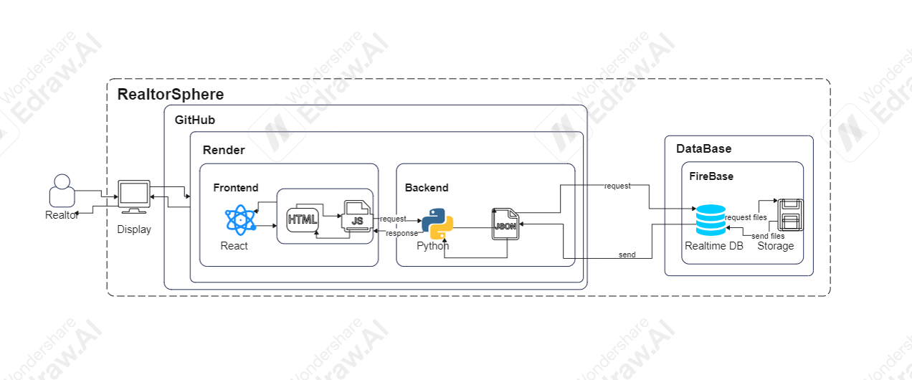

Main Functions in the Project:

Get_properties:

* Input: ownerName, roomNumberFrom, roomNumberTo, priceFrom, priceTo, city, propertyType, transactionType, email, and address.
* Output:A list of filtered properties, where each property is represented as a dictionary.
* Process: The process for the get_properties function begins by initializing Firebase references for properties, ownerships, and users to retrieve the necessary data. It fetches all properties from properties_ref, ownership records from ownerships_ref, and users (owners) from users_ref. The function returns an empty list if any required data is missing. The function then iterates over each property, retrieving details like the number of rooms, price, city, property type, size, parking, and more. It also extracts the owner's name from the ownership data using the property ID. During the iteration, properties are filtered based on various criteria, such as the realtor’s email, the city, the owner’s name, room number range, price range, property type, and address. Properties that meet all the specified filters are added to the filtered_properties list. Finally, after iterating through all properties, the function returns the list of filtered properties.

Get_filtered_persons

* Input: name, person_id, tab, email
* Output: a list of filtered persons, where each person is represented as a dictionary containing details such as their id, FirstName, LastName, Phone, email, Type, and city. If no persons are found or an error occurs, it returns None along with an error message.
* Process: The get_filtered_persons function begins by retrieving all persons from the Firebase database. If no data is found, it returns None and an error message. The function then iterates over each person and filters them based on the type specified in the tab parameter, either "owners" or "clients," ensuring the realtor's email matches the one provided. Afterward, the function applies additional filters: it checks whether the person’s name contains the search term, and whether the person_id matches the current person. If a person passes all filters, they are added to the filtered_list. Finally, the function returns the filtered list of persons or None if an error occurs.

Get_deals:

* Input: email
* Output: A list of filtered deals, where each deal is represented as a dictionary containing the id of the deal, the owner name, the client name, and the property. If no deals or users are found, it returns an empty list and None. If an error occurs, it returns None and an error message.
* Process: The get_deals function starts by retrieving all deals and users from the Firebase database. It checks if either the deals or users are missing, in which case it returns an empty list. The function then iterates through all the deals and filters them based on the realtor's email, ensuring that only deals associated with the provided email are processed. For each deal, it fetches the owner's and client's names using their respective IDs from the user data. It appends these details, along with the deal's ID and the property ID, to the list of deals. After processing all deals, the function returns the list of filtered deals or an error message if any exceptions occur.

Add_property:

* Input: data, file, realtor_email.
* Output: JSON response indicating either success with a message {"message": "Property added successfully"} or an error with a message {"error": "An error occurred while adding the property"} and an appropriate HTTP status code (200 for success, 500 for failure).
* Process: The add_property function begins by extracting necessary property details from the form data (data), such as price, street, city, house, neighborhood, size, number of rooms, air conditioning, accessibility, age, bars, number of floors, and other relevant property attributes. These details are structured into a property_data dictionary, which is then pushed to the Firebase database, creating a new property entry. The ownership information, including the owner ID, property ID, transaction type, and start date, is also stored in the Ownership collection in Firebase. The function then checks if any files (pictures) were uploaded as part of the request and uploads each file to Firebase Storage, generating public URLs for the images. These URLs are then saved in the pictures field of the property record in Firebase. Finally, the function returns a success message if everything is processed correctly or an error message if something goes wrong during the process.

Send_password_reset_email /send_email_with_attachment:

* Input: realtor email, realtor
* Output: email with user password
* Process: The send_password_reset_email function begins by creating an SMTP session to send an email. It connects to Gmail's SMTP server using the smtplib.SMTP class on port 587, then starts TLS encryption for secure communication. The function logs into the email account "RealtorSphereHelp@gmail.com" using the provided credentials. Next, it constructs the email content, including the subject ("Your Password Reset Request") and the body, which contains the password for the user. The message is then formatted with both the subject and the body. Using the sendmail method, the function sends the crafted email to the recipient's email address (email). After sending the email, the session is closed, and the function returns True if the email was sent successfully. If any exceptions occur, the function catches the error, logs the failure, and returns False.

Register_user:

* Input: first_name, last_name, id_number, phoneprefix, phone, email, password, password_repeat, license_number
* Output: a tuple where the first value is either 'success' or 'error', and the second value is a message.
* Process: The register_user function starts by verifying that the provided passwords (password and password_repeat) match. If they do not, the function returns an error indicating the passwords do not match. It then concatenates phonePrefix and phone to create the full phone number, which is stored as a string. The function prepares the user's data, including their first and last name, phone number, email, and license number. The data is structured to include the user's type which is realtor, and password. The function checks if the provided id_number already exists in the database, returning an error if so. It also checks if the provided email already exists in the system by querying the database for any users with a matching email. If both checks pass, the new user's data is saved in Firebase under the provided id_number. If the registration succeeds, the function returns a success message; if an error occurs during registration, it catches the exception and returns an error message explaining the issue.

Login_user:

* Input: realtor email, password
* Output: automation session, JWT token
* Process: The login_user function begins by checking if the email and password fields are populated. If either field is empty, it returns a 400 status code with a message requesting the user to fill in all fields. The function then retrieves all users from the Firebase Person collection. If no users are found, it returns a 500 status code with an error message. It iterates over the user data to find a matching email. If the email exists, it checks whether the user is of the type "Realtor." If the user's type is correct, the function checks if the provided password matches the one stored in the database. If the password matches, it returns a success message (200). If the password is incorrect, it returns a 401 status code with an error message about the wrong password. If no matching user is found, it returns a 404 status code. If any exceptions occur, the function catches them and returns a 500 status code with an appropriate error message.

match_Algo:

-Input: selected user data, realtor’s email

-Output: 3 top-matched properties

-Process: The match_Algo function first retrieves the client information based on the provided client ID from Firebase. It also gathers a list of all clients associated with the logged-in realtor, as well as the properties owned by the realtor. The function extracts relevant client details, such as budget, room and size preferences, and property type, and then constructs a vector to represent the client's preferences. For each property owned by the realtor, the function extracts the relevant data (e.g., number of rooms, price, size) and constructs a vector to represent the property. The cosine similarity between the client and property vectors is calculated to identify the best-matching properties. The top three properties with the highest similarity scores are selected and outputted.

Additionally, the function performs collaborative filtering using an interaction matrix, where each client-property interaction is represented as a matrix entry. It uses k-Nearest Neighbors (k-NN) to find similar clients based on this matrix, recommending properties that other similar clients have interacted with but the target client has not. Finally, a hybrid score is computed by combining the similarity scores and collaborative filtering scores, and the top three properties are recommended based on these hybrid scores. The function returns the list of matched properties.

scrape_yad2_listings:

* Input: max_listings
* Output: A list of property listings, where each listing is represented as a dictionary containing propertyType, price, city, rooms, and link. If any errors occur during the scraping process, the function returns the listings collected up to that point.
* Process: The scrape_yad2_listings function begins by defining the base URL for scraping property listings from the Yad2 real estate site. It starts with an empty listings list and initiates scraping on page 1. The function constructs the URL for each page and sends an HTTP GET request to retrieve the content. Upon receiving a successful response, it parses the HTML content using BeautifulSoup and searches for property cards based on specific HTML classes. For each card found, the function extracts details such as property type, price, city, number of rooms, and the property link. These details are stored in a dictionary and appended to the listings list. The function continues scraping until it either collects the desired number of listings (max_listings) or encounters a problem, such as a request failure or a change in the page structure. After the scraping process is complete, the function returns the list of scraped property listings. If any errors occur, it handles them by printing the error message and terminating the process.

Archive_property:

* Input: property-id, archive_reason
* Output: a JSON response, either confirming success with a message {"message": "Property archived successfully"} and a 200 status code, or returning an error message such as {"error": "Property not found"} with a 404 status code, or {"error": "An error occurred while archiving the property"} with a 500 status code if an exception occurs.
* Process: The archive_property function begins by retrieving the property data from the Firebase database using the property_id. If the property does not exist, the function returns a 404 error. If the property is found, it updates the property's status to "archived" and stores the reason for archiving in the archiveReason field. After updating the property, the function queries the Ownership collection to find the ownership record associated with the property_id. For each ownership record found, it updates the endDate field with the current date. If the process is completed successfully, the function returns a success message. If any exceptions occur during the process, the function catches the exception and returns a 500 error message indicating that an error occurred while archiving the property.

Maintenance:

* Create a profile editing page.
* Create a page to save frequently used files.
* Improve matching algorithm performance.
* Instead of matching the properties page create an alarm system that will notify the realtor.
* Improve design and application performance for more users in the future.
* Get a contract with a third-party website for real estate like yad2 and Madlan to create external DB for potential customers and Lidim.
* Get access to an active realtor DB so the application can check sign-up realtors before approving their application.
* Saving reports to DB
* Add more test
* Make the home screen more responsive

**Tests:**

| TestID | Description | Expected Result | Precondition | Comments |
| --- | --- | --- | --- | --- |
| **login:** |  |  |  |  |
| LoginSuccess | Login with valid credentials | User is logged in and navigated to the home page. DB is changed the status as "Logged in". | User is defined in DB. | Tests successful login with correct email and password. |
| LoginFailWrongPassword | Login with valid email but incorrect password | Error: Incorrect password. User didn’t log in to the system. | User is defined in DB, but password does not match. | Verifies that an incorrect password prevents login. |
| LoginFailUserNotFound | Login with email not found in the database | Error: User not found. User didn’t log in to the system. | User isn’t defined in DB. | Ensures login fails if the email does not exist in the database. |
| LoginMissingCredentials | Login with missing email or password | Error: Please fill in all fields. User didn’t log in to the system. | User email or password field is empty. | Tests the response to incomplete login credentials. |
| **forgotPass**: |  |  |  |  |
| ForgotPassSuccess | Correct email and ID provided | Password reset email sent successfully. Status code 200. | User exists in DB with given email and ID. | Verifies that a password reset email is sent when correct details are provided. |
| ForgotPassIncorrectEmail | Incorrect email provided | Error message for non-matching fields. Status code 400. | User exists in DB but with a different email. | Ensures error is returned if email does not match the ID in DB. |
| ForgotPassIncorrectID | Incorrect ID provided | Error message for non-matching fields. Status code 400. | User exists in DB but with a different ID. | Checks for error when ID does not match the email in DB. |
| SendEmailSuccess | Attempt to send reset email succeeds | True returned, indicating email was sent successfully | SMTP server responds without error. | Tests successful connection and sending with SMTP server. |
| SendEmailFail | SMTP error occurs | False returned, indicating failure to send email. | SMTP error occurs during sending. | Simulates an SMTP server error and checks handling of email sending failures. |
| EmptyEmailField | Email field left empty | Error message for missing fields. Status code 400. | Email field is empty. | Ensures that the system prompts for missing email. |
| EmptyIDField | ID field left empty | Error message for missing fields. Status code 400. | ID field is empty. | Ensures that the system prompts for missing ID. |
| BothFieldsEmpty | Both email and ID fields are empty | Error message for missing fields. Status code 400. | Both email and ID fields are empty. | Tests the response when all fields required for reset are missing. |
| **Registration:** |  |  |  |  |
| test_register_user_success | Register with valid credential | Success: 'הרשמה הצליחה!' | User does not exist in the database (ID or email not found). | Tests successful registration with valid inputs. |
| test_register_user_password_mismatch | Register with passwords that do not match | Error: 'סיסמאות לא תואמות' |  | Verifies that a password mismatch prevents registration. |
| test_register_user_existing_id | Register with an existing ID in the database | Error: 'המספר כבר קיים במערכת' | User ID already exists in the database. | Ensures registration fails if the user ID is already in the system. |
| test_register_user_firebase_exception | Register with valid data but encounters a Firebase exception | Error: 'שגיאה בהרשמה: Firebase error' | Firebase system error occurs when setting user data. | Simulates and verifies behavior when a Firebase exception happens during registration. |
| **Property: get_property** |  |  |  |  |
| test_get_properties_no_filters | Test fetching properties without any filters | Return properties list with the one property from mock data | User has properties in the database. Firebase mock returns one property with detailed specifications. | Ensures that the properties are returned correctly when no filters are applied. |
| tset_get_properties_with_filters | Test fetching properties with filters such as city and room numbers | Return filtered properties list that match the filter criteria (e.g., city='Tel Aviv', rooms between 2-4) | Mock Firebase data contains properties that match the filter criteria. | Verifies that properties are correctly filtered by city and number of rooms. |
| test_get_properties_no_result | Test fetching properties where no results are found (e.g., no matching properties in Firebase | Return an empty list ([]) because no properties match the query or the database is empty | Firebase mock returns no properties (empty responses). | Ensures that the system handles scenarios where no properties are found and returns an empty list. |
| get_property_by_id |  |  |  |  |
| test_get_property_id_success | Test fetching a property by its ID when the property exists | Return the property details corresponding to the provided ID | Firebase mock returns a valid property. The property ID exists in the database. | Verifies the successful retrieval of a property by its ID, ensuring the correct Firebase path is queried. |
| test_get_property_by_id_not_found | Test fetching a property by its ID when the property does not exist | Return none because the property with the given ID does not exist in the Firebase database. | Firebase mock returns noneindicating the property ID is not found in the database. | Ensures the system correctly handles cases where the property ID does not exist, returning none instead of failing or throwing an error. |
| add_property |  |  |  |  |
| test_add_propert_exception | Test that an exception during property addition is handled | Returns {"error": "An error occurred while adding the property"}, status 500 | - Mock Firebase database to raise an exception during the .child() call. | Ensures that any exceptions during the property addition process are properly caught and handled, returning the appropriate error message. |
| test_add_property_success | Test adding a property with valid form and file data | Returns {"message": "Property added successfully"}, status 200 | - Mock Firebase database to simulate saving property data.  - Mock Firebase storage to simulate file upload. | Verifies that the property data is correctly pushed to the Firebase database and that the file upload to storage is successful. |
| test_add_property_no_files | Test adding a property with no file provided | Returns {"message": "Property added successfully"}, status 200 | Mock Firebase database to simulate saving property data.  - No file data should be provided. | Verifies that the property can still be added successfully even when no files are provided, and ensures no storage interactions occur. |
| remove_picture |  |  |  |  |
| test_remove_picture_success | Test successful removal of a picture from both Firebase Storage and Database | Returns {"message": "Picture deleted successfully"}, status 200 | - Mock Firebase storage and database reference.  - Picture file and database entry exist for the property. | Ensures that both the picture file and the corresponding entry in the Firebase database are deleted successfully. |
| test_remove_picture_exception | Test that an exception during picture removal from storage is handled | Returns {"error": "An error occurred while deleting the picture"}, status 500 | - Mock Firebase storage to raise an exception during the .delete() call.  - The database entry is still present. | Verifies that if Firebase Storage raises an exception during file deletion, the function handles it correctly and returns an error. |
| test_remove_picture_db_exception | Test successful picture removal from storage but failure in database | Returns {"error": "An error occurred while deleting the picture"}, status 500 | - Mock Firebase storage to delete the picture successfully.  - Mock Firebase database to raise an exception during deletion. | Verifies that if the file is deleted successfully but the database entry deletion fails, the function handles the exception properly. |
| add_picture_to_property |  |  |  |  |
| test_add_pictures_to_property_success | Test successful upload of multiple pictures to Firebase Storage and update in Firebase Database | Returns {"message": "Pictures uploaded successfully"}, status 200 | - Mock Firebase storage and database reference.  - Two mock picture files (image1.png and image2.png) are provided. | Ensures that both picture files are uploaded to Firebase Storage and their URLs are saved in the Firebase Database under the pictures field for the property |
| test_add_pictures_to_property_exception | Test that an exception during the upload process is handled | Returns {“error”: “An error occurred while uploading the pictures”} status 500 | - Mock Firebase storage to raise an exception during the .upload_from_file() call.  - One mock picture file is provided. | Verifies that if Firebase Storage raises an exception during file upload, the function handles it and returns an appropriate error response. |
| update_property |  |  |  |  |
| test_update_property_success | Test successful property update including ownership record update | Returns {“message”: “Property updated successfully”}, status 200 | - Mock Firebase DB reference.  - Property data is updated.  - No files involved. | Verifies that the property data and the ownership record are updated properly in Firebase Database, and the appropriate success message is returned. |
| test_update_property_with_files | Test property update when new files (pictures) are provided | Returns {“message”: “Property updated successfully”}, status 200 | - Mock Firebase DB reference.  - Mock picture files provided.  - No picture deletion involved. | Ensures that new pictures are successfully uploaded and added to the property record in Firebase, and the property is updated as expected. |
| test_update_property_delete_pictures | Test property update when pictures are deleted | Returns {“message”: “Property updated successfully”}, status 200 | - Mock Firebase DB reference.  - Existing property has pictures.  - A picture deletion is requested. | Ensures that specified pictures are successfully removed from Firebase and the property data is updated as expected. |
| test_update_property_rooms_preserved | Test updating property while preserving the existing room details | Status code 200, message {“message”: “Property updated successfully”}, existing rooms should be preserved | Property exists with rooms in Firebase | Verifies that when updating the property, the existing rooms information remains unchanged in the update process. |
| **ClientProfessionalPage get_filtered_person** |  |  |  |  |
| test_no_person_found | Test when no persons are found in the Firebase DB | filtered_list=None, error=’No persons founs in the database.’ | No persons exist in the Firebase database | Ensures that the function correctly handles the case where no persons are found. |
| test_filter_by_name | Test filtering persons by name | Filtered_list with a person with the first name | Firebase contains the person to be filtered. | Ensures the function filters correctly by first name and returns only matching persons. |
| test_filter_by_city | Test filtering persons by city | Filtered_list with people from that city. | Firebase contains a person from that city | Verifies filtering works based on the city. Only people from the specified city should be returned. |
| test_filter_by_id | Test filtering persons by a unique ID | Filtered_list with the person with that ID | Firebase contains a person with that ID. | Ensures that the function correctly retrieves a person using their unique ID. |
| test_error_fetching_persons | Test handling errors when fetching data from Firebase | filtered_list= None, error=’ An error occurred while fetching persons | Simulate an exception in the Firebase DB (side effect) | Ensures that the function handles unexpected errors during data fetching and returns an appropriate error message. |
| add_person |  |  |  |  |
| test_add_person_owner_success | Test successfully adding a person as an owner | status=200, response[“ message”]=” Person added successfully” | No person with the given ID exists in Firebase | Verifies that the person is correctly added to Firebase as an owner. |
| test_add_person_client_success | Test successfully adding a person as a client | status=200, response[“ message”]=” Person added successfully” | No person with the given ID exists in Firebase | Verifies that the person is correctly added to Firebase as a client, with all relevant fields such as budget and cities. |
| test_add_person_already_exists | Test handling when a person with the same ID already exists | status=400, response[“ error”]=” Person with this ID already exists” | A person with the same ID already exists in Firebase | Ensures that no duplicate entries are created in Firebase when a person with the same ID is already present. |
| test_add_person_error_handling | Test error handling when an exception occurs while adding a person | status=500, response[“ error”] contains “An error occurred while adding the person” | No person with the given ID exists, but an exception occurs during the set operation | Simulates an error while adding a person to Firebase and verifies that the appropriate error response is returned. |
| update_person_details |  |  |  |  |
| test_update_person_details_success | Test successfully updating person details | status=200, response[“message”]=” Person updated successfully” | Person exists in Firebase | Verifies the successful update of person details, including handling owner and client types. |
| test_update_person_details_not_found | Test handling when person ID is not found | status=404, response[“message”]=”Person not found” | No person with the given ID exists in Firebase | Ensures proper handling of cases where the person with the given ID does not exist in Firebase. |
| test_update_person_details_exception | Test error handling when an exception occurs during update operation | status=500, response[“message”] starts with “An error occurred while updating this person” | Exception occurs during the Firebase operation | Simulates an error scenario when updating the person in Firebase and ensures that an appropriate error message is returned. |
| get_person_details |  |  |  |  |
| test_get_person_details_success_client | Test successfully fetching person details for a client | error=None, result[‘id’]=person_id, result[‘FirstName’]=”Eli”, result[‘PropertiesLiked’] contains 2 properties. | Person exists in Firebase and is a client | Verifies successful retrieval of a client's details, including liked properties, without any properties owned. |
| test_get_person_details_not_found | Test handling when person is not found | result=None, error=”Person not found” | No person with the given ID exists in Firebase | Ensures that the function properly handles the case where the person with the provided ID is not found. |
| test_get_person_details_exception | Test error handling during person details retrieval due to exception | result=None, error starts with “An error occurred while fetching person details” | Exception occurs during Firebase operation | Simulates an error during the Firebase query and verifies that an appropriate error message is returned. |
| update_person_details |  |  |  |  |
| test_update_person_details_success | Test successful update a person’s details | Status code 200, message {“message”:”Person updated successfully”} | The person exists in the Firebase | Verifies that the person details are correctly updated |

**מדריך משתמש:**  
**תיאור המערכת:**

ברוכים הבאים ל - "RealtorSphere", המערכת מספר אחת למתווכי נדל"ן. "RealtorSphere" זו מערכת מידע לניהול קשרי לקוחות המותאמת לצרכי מתווכי נדל"ן על מנת לעזור להם בעבודתם. בעזרת התוכנה הזו מתווכים יכלו לנהל את הנכסים והלקוחות שלהם בצורה נוחה יותר, להתאים נכסים לקונים פוטנציאליים בצורה יעילה יותר, להשיג מידע על נכסים ממקורות אחרים, לנהל מסמכים ודו"חות, לנהל אנשי קשר, לשלוח ולקבל הודעות למערכת ולעקוב אחר הצעות מחיר של המוכרים והקונים. המערכת בנויה בצורה נוחה לשימוש כך שיהיה קל ללמוד להשתמש בה.

**הוראות שימוש:**

מסך התחברות:

  
  
מסך ההתחברות הוא המסך הראשון במערכת. על כל מתווך שרוצה להשתמש במערכת להירשם וליצור לעצמו חשבון.

על מנת להתחבר למערכת:

1. הכנס אימייל לשדה ה- "אימייל".
2. הכנס סיסמה לשדה ה- "סיסמה"
3. שדה ה- "סיסמה" מאובטח ולכן לא יציג את הסיסמה של המשתמש אלה רק כוכביות.
4. תוודא שהפרטים שהכנסתה נכונים.
5. במידה וההתחברות לא הצליחה, המערכת תציג שגיאה עם סיבת הכישלון.
6. קרא את סיבת השגיאה ונסה להתחבר שנית.
7. במקרה שהשגיאה היא "סיסמה לא נכונה" נסה להתחבר עם סיסמה נכונה או אם אינך זוכר את סיסמתך, תבחר באפשרות "שכחתי סיסמה".
8. אם סיבת השגיאה "משתמש לא קיים", כנראה כתובת האימייל הינך מנסה להתחבר איתה לא קיימת במסד נתונים. לכן עליך לתקן אותה או להירשם באפשרות "אין משתמש? הירשם עכשיו"



במסך זה מתואר מצב נכון של התחברות. המשתמש רשום במערכת, השדות מלאים ופרטי ההתחברות שלו נכונים.

  
במסך זה, השדה של הסיסמה לא מלא, ולכן אי אפשר להתחבר וקופצת הודעת שגיאה מתאימה.

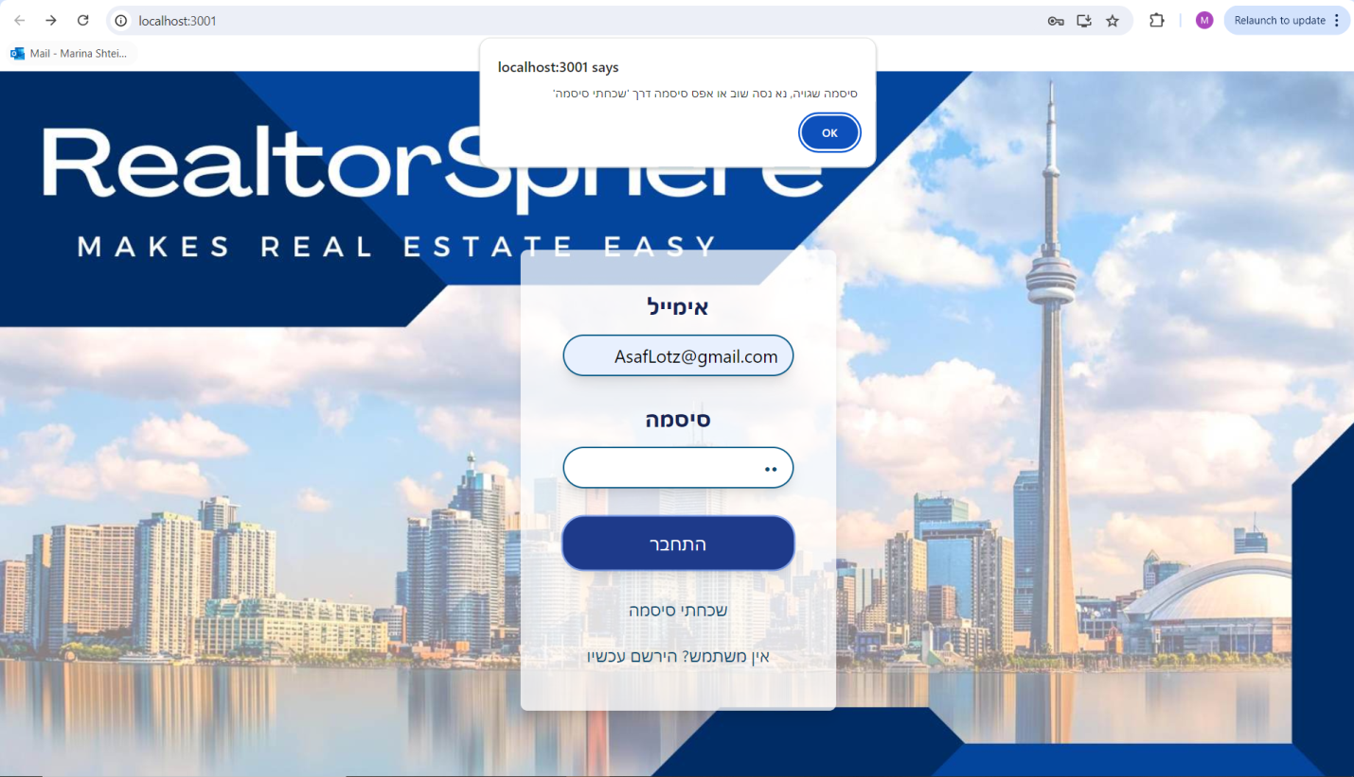

במצב זה, הסיסמה שהוכנסה שגויה, ולכן ההתחברות נכשלה ומוצגת הודעה מתאימה למשתמש.

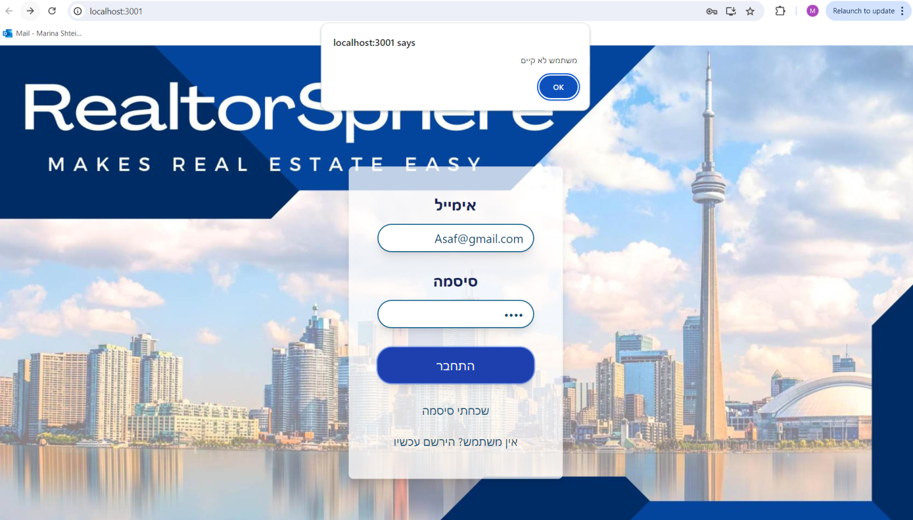

במקרה זה, המשתמש לא רשום במערכת ולכן התוכנה לא מזהה את האימייל. מוצגת הודעה ועל המשתמש להירשם.

מסך הרשמה:  
  
בחלון זה משתמש חדש יכול להירשם למערכת. על מנת להירשם בהצלחה:

1. בשדה "שם פרטי" הכנס את שמך הפרטי.
2. בשדה "שם משפחה" הכנס את שם משפחתך.
3. בשדה "תעודת זהות" הכנס את תעודת הזהות שלך. השדה זה חייב להכניס 9 תווים ומספרים בלבד. תווים אחרים יקפיצו שגיאה וכך גם מספר שונה של תווים (בכל מקרה מערכת לא תאפשר לרשום יותר מ 9 תווים). בנוסף אם תעודת הזהות קיימת במסד נתונים, המערכת תתריע על כך וההרשמה לא תצליח משום שתעודות הזהות חייבות להיות שונות אחת מהשנייה.
4. בשדה "טלפון" הכנס את מספר הטלפון שלך. השדה הזה כמו הקודם מאפשר כתיבה של מספרים בלבד וכמו בנוסף לקידומת מאפשר להוסיף 7 מספרים בלבד. מספר שונה של תווים או תווים לא חוקיים יקפיצו הודעת שגיאה וההרשמה לא תצליח.
5. בשדה "אימייל" הכנס את כתובת האימייל שלך. המערכת תתריע אם האימייל קיים כבר במערכת. המערכת, כמו כן, מוודא את תקינות האימייל ותקפיץ הודעת שגיאה אם האימייל אינו תקין.
6. בשדה "סיסמה" הכנס סיסמה לבחירתך. על מנת שההרשמה תצליח על הסיסמה להיות זהה לסיסמה בשדה "וידוי סיסמה".
7. בשדה "וידוי סיסמה" הכנס סיסמה זהה לסיסמה בשדה "סיסמה". אם הסיסמאות לא זהות המערכת תתריע על כך.
8. בשדה "מספר רישיון" הכנס את רישויון התיווך שלך.
9. להשלמת הפעולה לחץ על הכפתור "הירשם".

מסך שכחתי סיסמא:

  
במסך זה מתווך יכול לקבל את סיסמתו אם הוא שכח אותה. על מנת לשחזר סיסמה:

1. הכנס לשדה "אימייל" את כתובת האימייל איתה נרשמת למערכת.
2. הכנס בשדה "תעודת זהות" את תעודת הזהות איתה נרשמת.
3. כך מערכת מאבטחת את המידע שלך ומוודא שאתה אכן המשתמש הרשום למערכת.
4. המערכת תבדוק את תקינות הפרטים. במקרה והפרטים לא נכונים המערכת תקפיץ הודעת שגיאה עם הסיבה.
5. תקרא את הודעת השגיאה ונסה שנית.
6. במידה הפעולה הצליחה, המערכת תתריע על כך שהודעה עם סיסמתך נשלחה למייל איתו נרשמת.

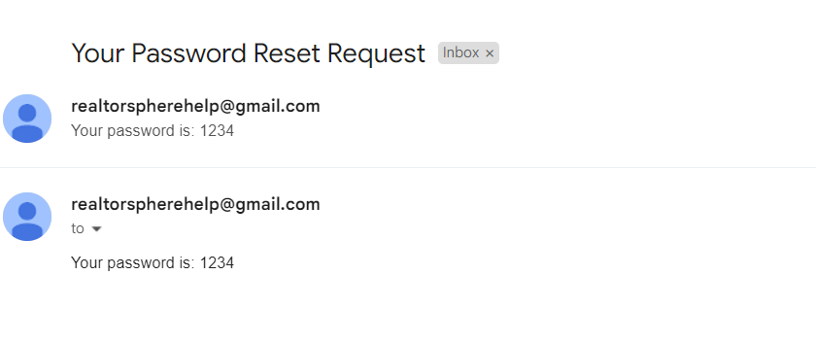  
כך תיראה הודעת האימייל עם הסיסמה להתחברות למערכת.

מסך הבית:

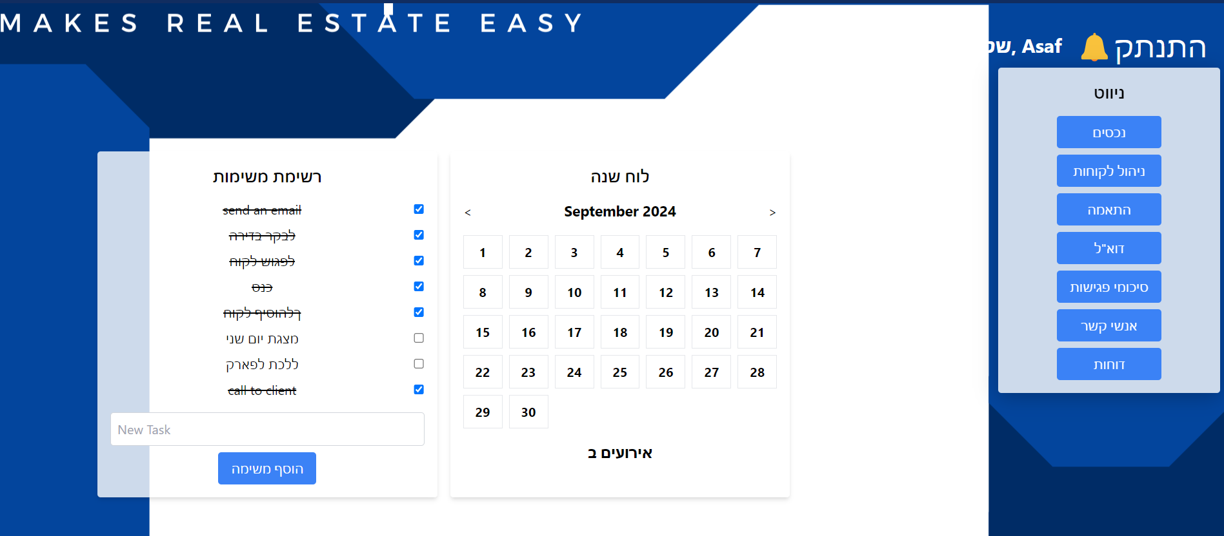  
זה הוא המסך הראשי של המערכת המופיע מיד לאחר ההתחברות. במסך הזה:

1. יש הודעת שלום למשתמש המחובר עם שמו הפרטי.
2. יש כפתור התנתקות במידה והמשתמש ירצה לצאת מהמערכת.
3. יש תפריט ניווט למסכים השונים של המערכת. בכל מסך ניתן לצפות במידה שונה ולעשות פעולות שונות.
4. קיימת רשימת משימות למשתמש המחובר שאיתה המתווך יכול לעקוב אחר המשימות שלו.
5. על מנת להוסיף משימה חדשה, הכנס לשדה "משימה חדשה", את המשימה אותה תרצה לזכור לעשות ולחץ על הכפתור "הוסף משימה".
6. במידה וסיימת משימה הינך יכול לסמן ב "V" בצ'אקבוקס ליד השורה הרלוונטית.
7. כמו כן יש לוח שנה בו המתווך יכול לשמור אירועים חשובים לפי תאריכים ושעה. המערכת תתריע למתווך 24 שעות ושעה לפני האירוע המיועד.   
     
   1. על מנת ליצור אירוע חדש לחץ על הלוח שנה.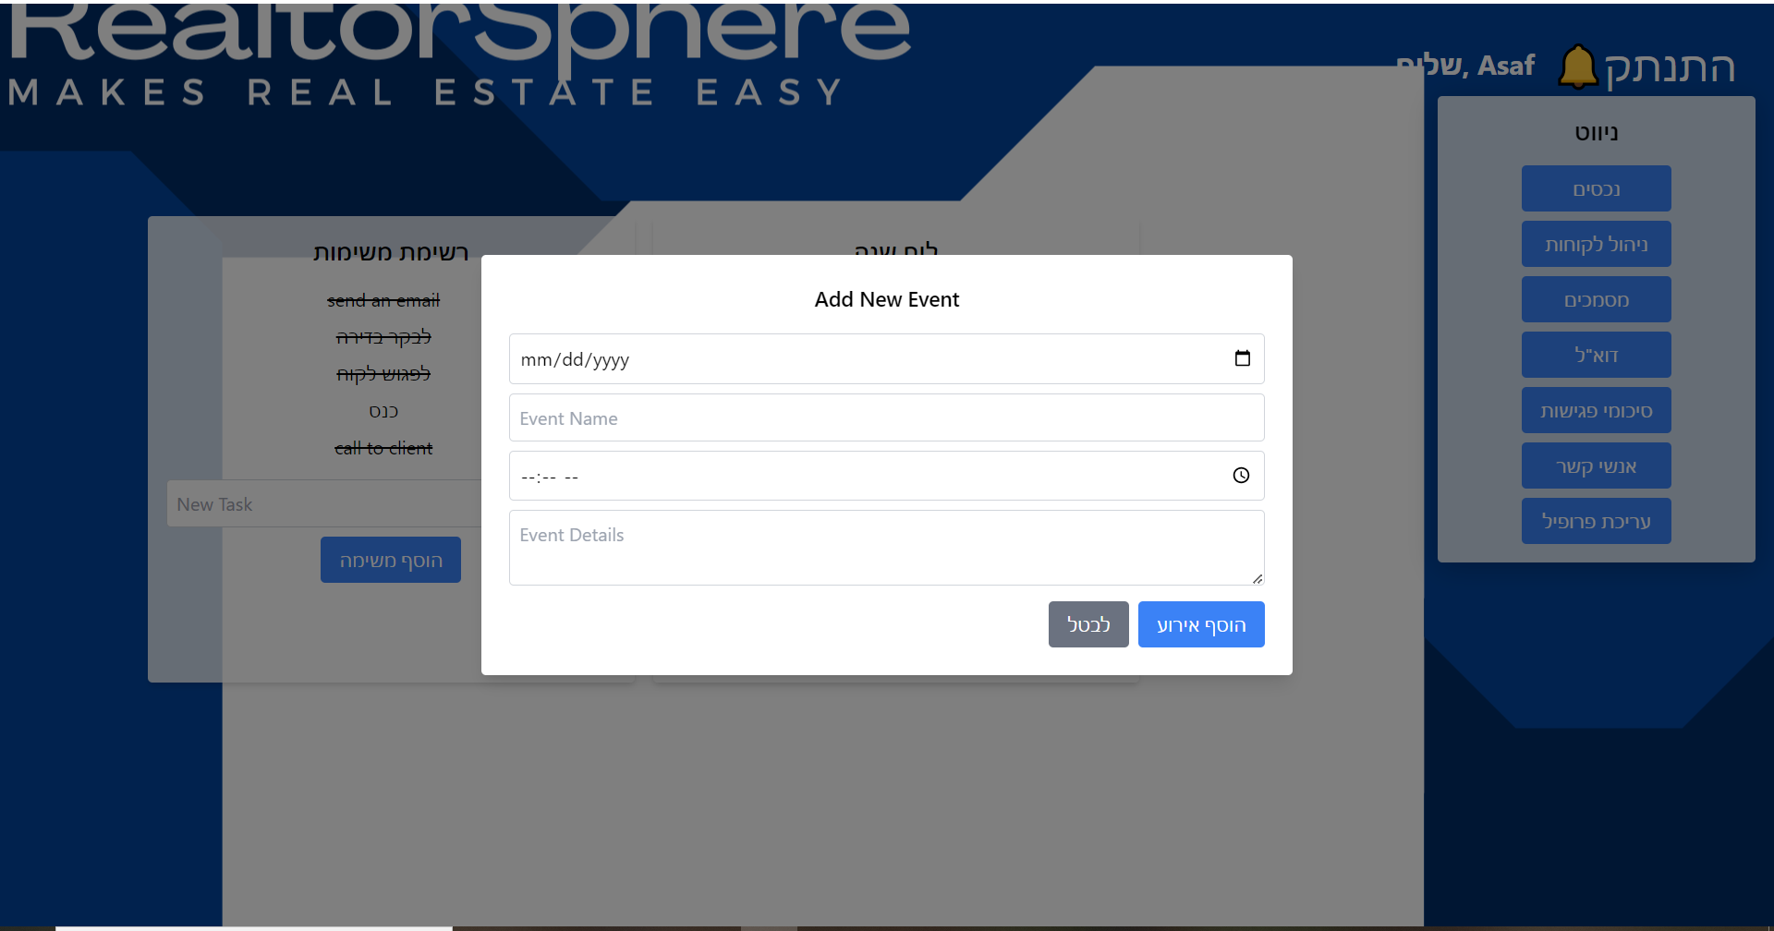

2. בחר בתאריך הרצוי בשדה הראשון.

3. הכנס לשדה "שם האירוע" את השם שתבחר לאירוע שלך.

4. בשדה השלישי הכנס שעה רצויה.

5. בשדה "פרטים" הכנס את פרטי האירוע.

6. הינך יכול לבטל את היצירה בכפתור "ביטול".

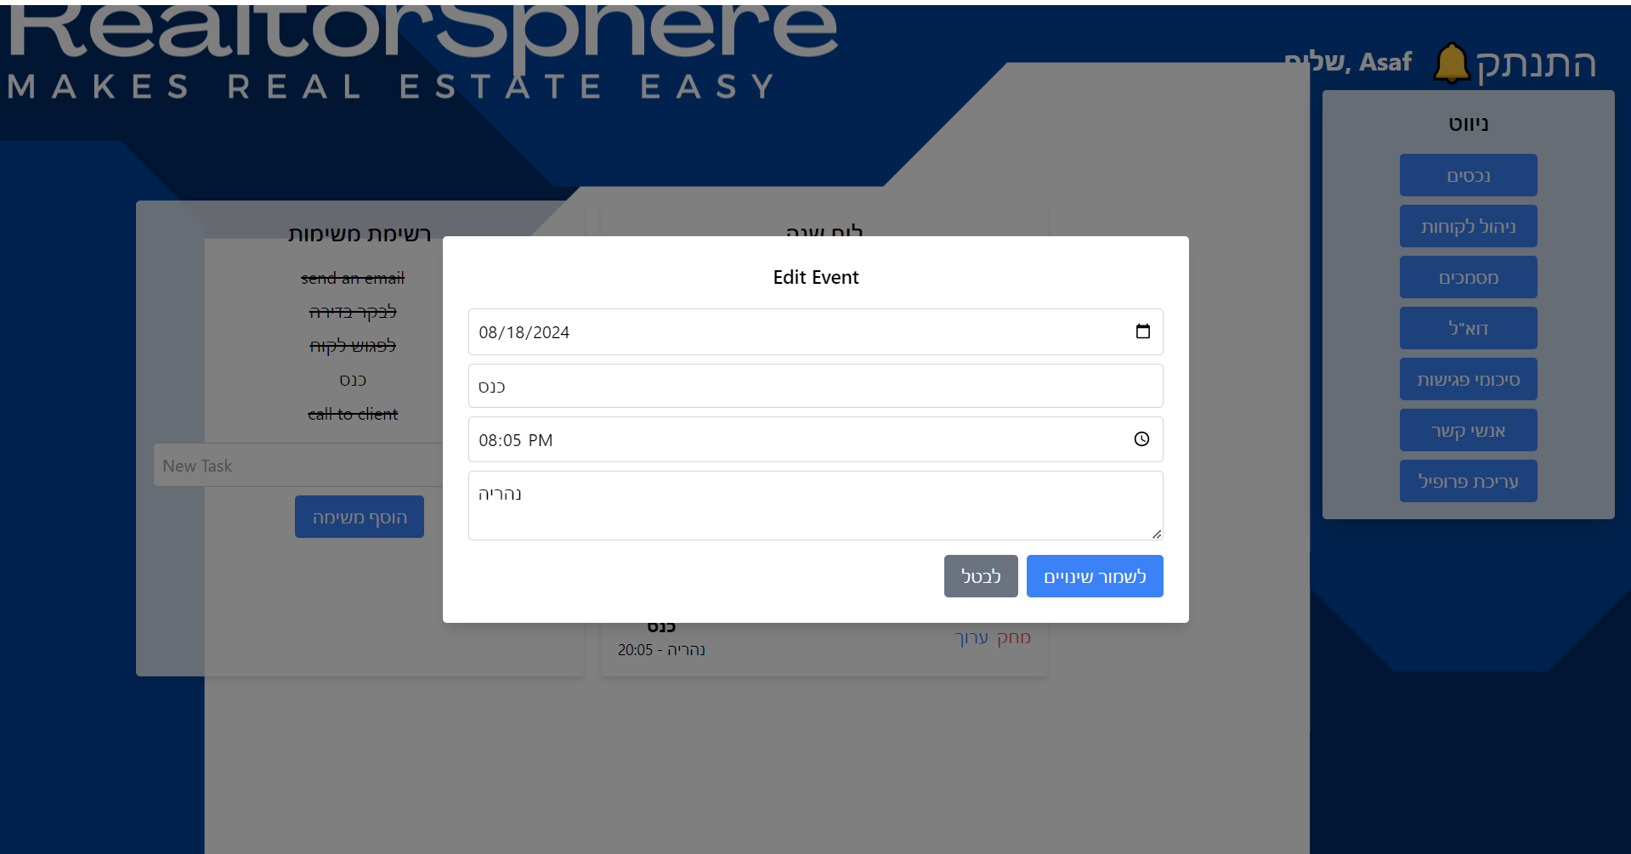  
אירוע שכבר קיים אפשר לערוך ברגע שבוחרים בו בלוח שנה בעזרת כפתור "ערוך" ואת השינויים אפשר לשמור או לבטל. כמו כן אירוע קיים אפשר למחוק.

נכסים:  
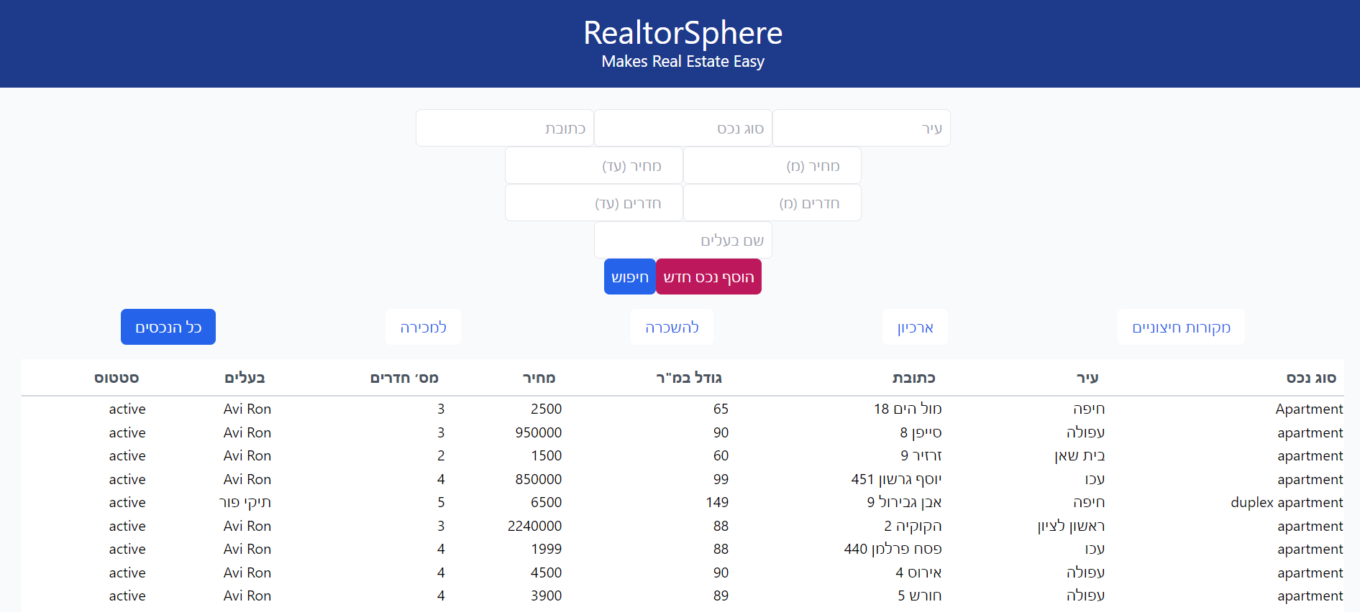  
בעמוד זה המתווך יכול לראות, להוסיף ולערוך את כל הנכסים שלו. טבלת הנכסים מחולקת לקטגוריות: כל הנכסים, למכירה, להשכרה, ארכיון ומקורות חיצוניים. בכל הנכסים אפשר לראות את כל הנכסים שהמסד נתונים שומר למתווך. במכירה הטבלה תציג נכסים למכירה בלבד ובהשכרה נכסים להשכרה. בארכיון יהיו נכסים שהעסקה עליהם הושלמה (נמכרו או הושכרו) או שמסיבה כלשהי הבעלים החליטו לבטל את העסקה עליהם. במקורות חיצוניים יהיו נכסים מאתרים כמו יד 2, הדף מיועד לפיתוח עתידי. הטבלה תציג תקציר על כל נכס: סוג הנכס, עיר, כתובת, גודל במ"ר, מחיר, מספר חדרים, בעלי הנכס וסטטוס הנכס( פעיל או בארכיון)  
לביצוע חיפוש של נכס:   
1. הזן בתיבות הטקסט את הפרמפטרים לפיהם יתבצע החיפוש (עיר, סוג הנכס, כתובת, תווך מחירים, תווך חדרים, שם בעלי הנכס).  
2. ניתן לחפש נכס באמצעות פרמטר אחד או באמצעות שילוב של מספר פרמטרים.  
3. לחץ על חיפוש.  
4. הטבלה תציג את הנכסים המתאימים לחיפוש בכל אחת מהקטגריות (כל הנכסים, למכירה, להשכרה וארכיון)   
  
  
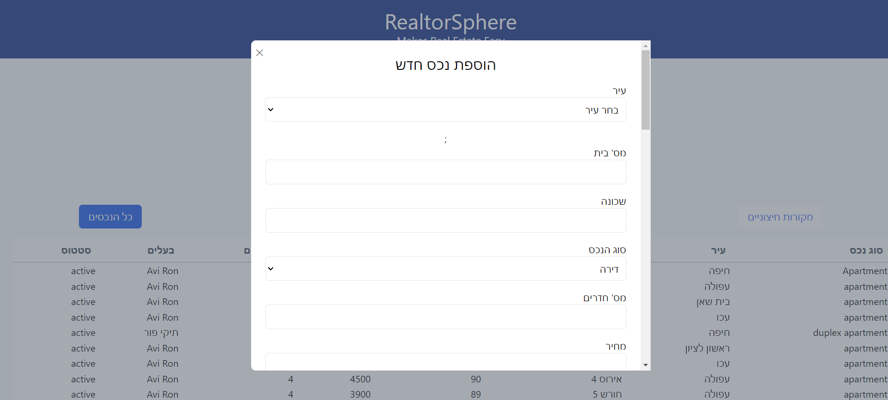  
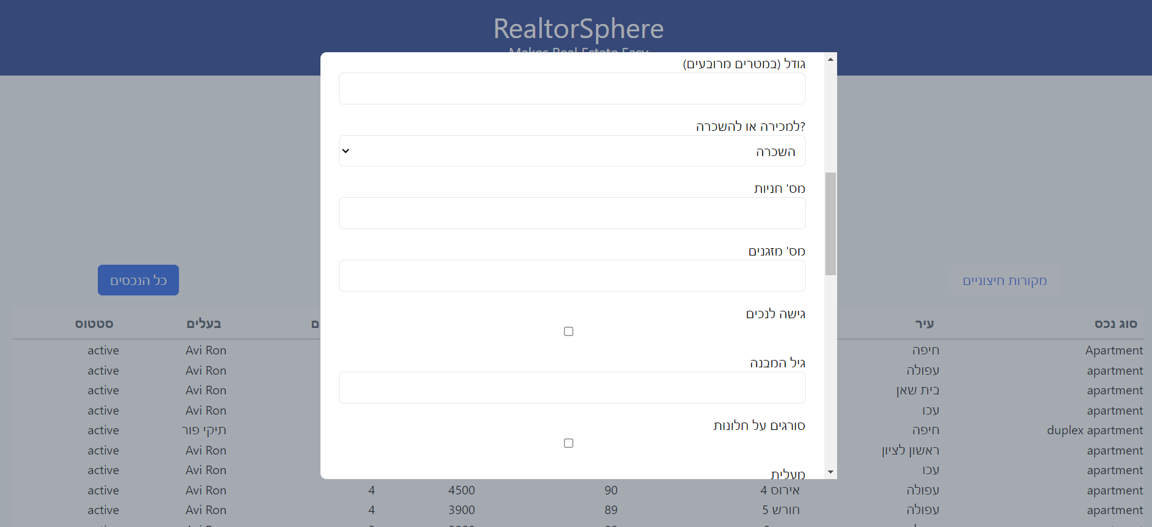  
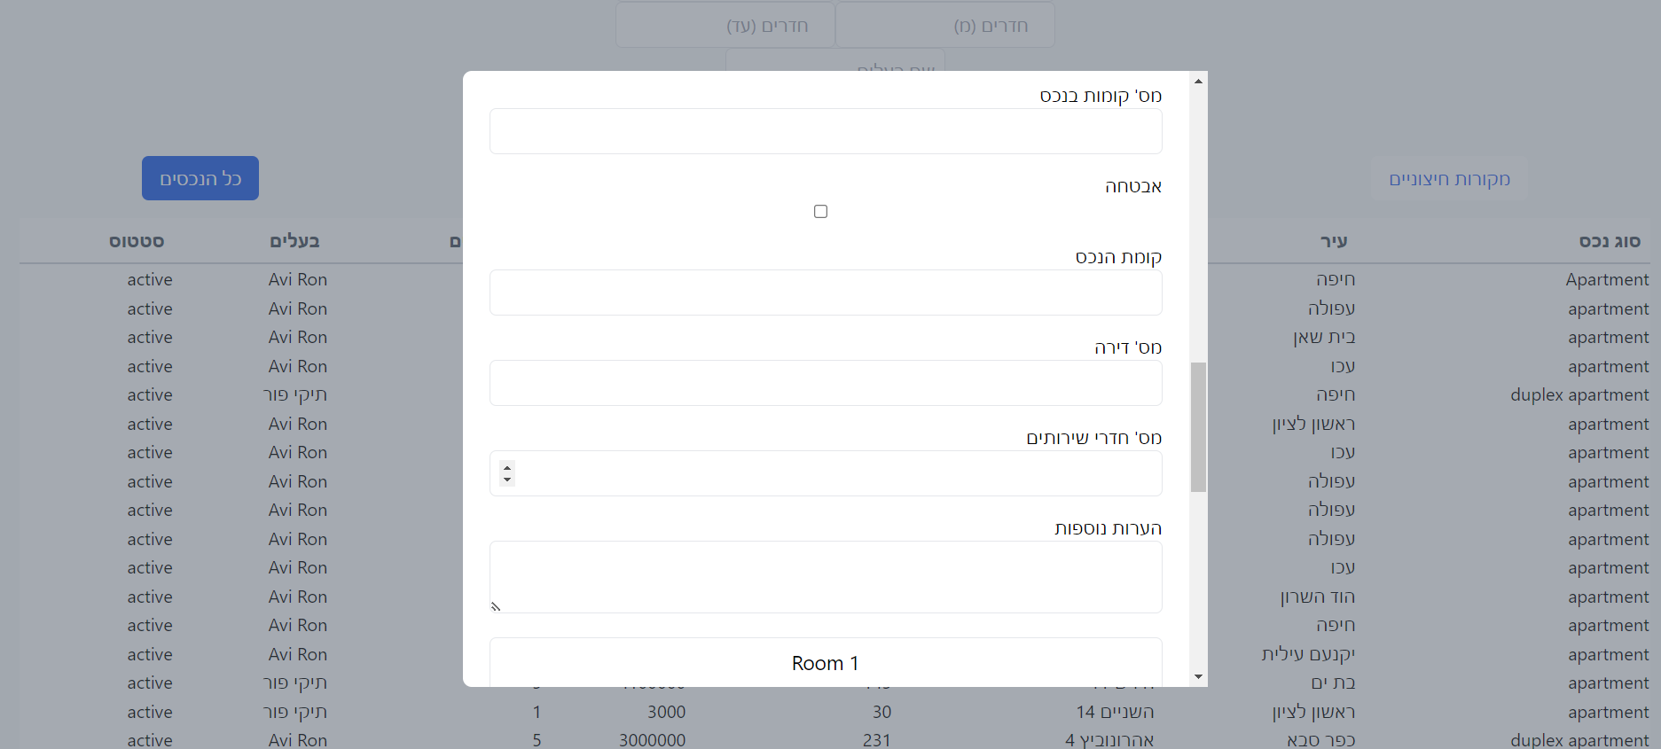  
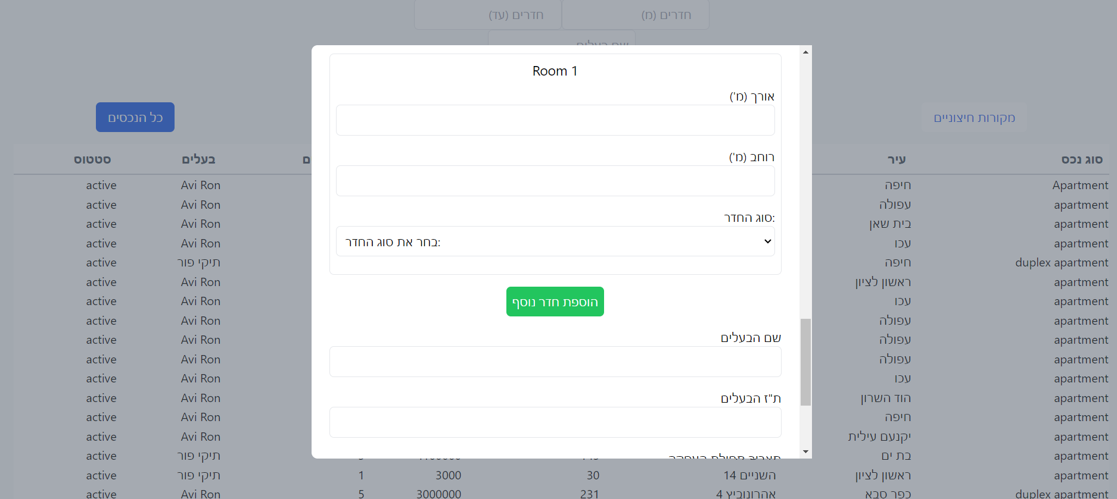  
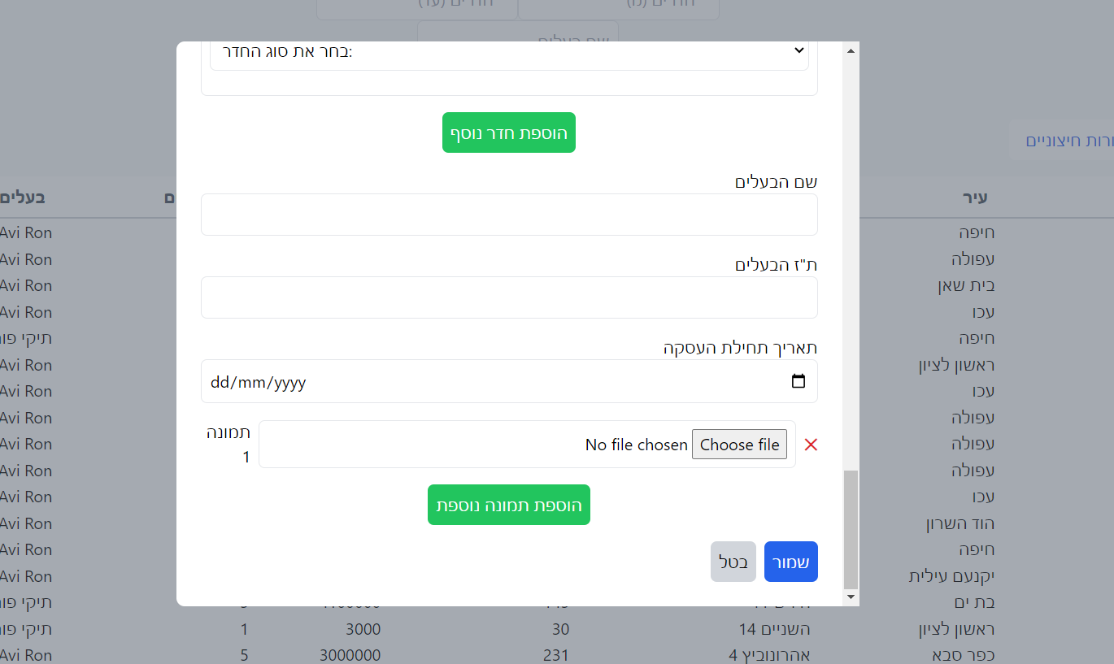  
להוספת נכס חדש:   
1. לחץ על הכפתור "הוסף נכס חדש".   
2. בחר עיר מרשימת הערים.  
3. לאחר בחירת עיר תופיע רשימה עם כל הרחובות בעיר זו, בחר את רחוב הנכס.   
4. רשום את מספר הבית.  
5. רשום את שם השכונה.  
6. בחר את סוג הנכס מהרשימה.   
7. רשום את מספר החדרים בנכס.   
8.רשום את מחיר הנכס.  
9. רשום את גודל הנכס במ"ר.  
10. בחר האם הנכס הוא למכירה או להשכרה.  
11. רשום את כמות החניות המשוייכות לנכס.

12. רשום את כמות המזגנים שיש בנכס.  
13. סמן "וי" אם יש בנכס גישה לנכים. אחרת השאר ריק.   
14. רשום רת גיל המבנה.  
15. סמן "וי" אם יש בנכס סורגים על החלונות. אחרת השאר ריק.   
16. סמן "וי" אם יש בנכס מעלית. אחרת השאר ריק.   
17. הזן את כמות הקומות בנכס הנמכר/מושכר.  
18. סמן "וי" אם יש לנכס אבטחה. אחרת השאר ריק.   
19. רשום את קומת הנכס. (0 עבור קרקע)   
20. רשום את מס הדירה.   
21. רשום את מספר חדרי השירותים.  
22. רשום הערות על הנכס (אופציונאלי).  
23. להוספת גדלים של החדרים לחץ על "הוספת חדר נוסף".  
24. רשום את אורך החדר.  
25. רשום את רוחב החדר.   
26. בחר את סוג החדר.   
27. חזור על כך עבור כל החדרים.   
29. רשום את שם הבעלים.  
30. רשום את תעודת הזהות של הבעלים.  
31. בחר את תאריך תחילת העיסקה. (ניתן לרשום ידנית או לבחור בלוח השנה)   
32. בחר תמונה מהקבצים להוספה לנכס. (אופציונאלי)   
33. אם ברצונך למחוק את תמונה זו, לחץ על האיקס האדום מימין.   
34. אם ברצונך להוסיף עוד תמונות, לחץ על "הוספת תמונה נוספת"   
35. לשמירה לחץ "שמור".  
36. לביטול לחץ "בטל".

37. לצפיה בפרטי הנכס יש ללחוץ על שורת הנכס בטבלה.  
  
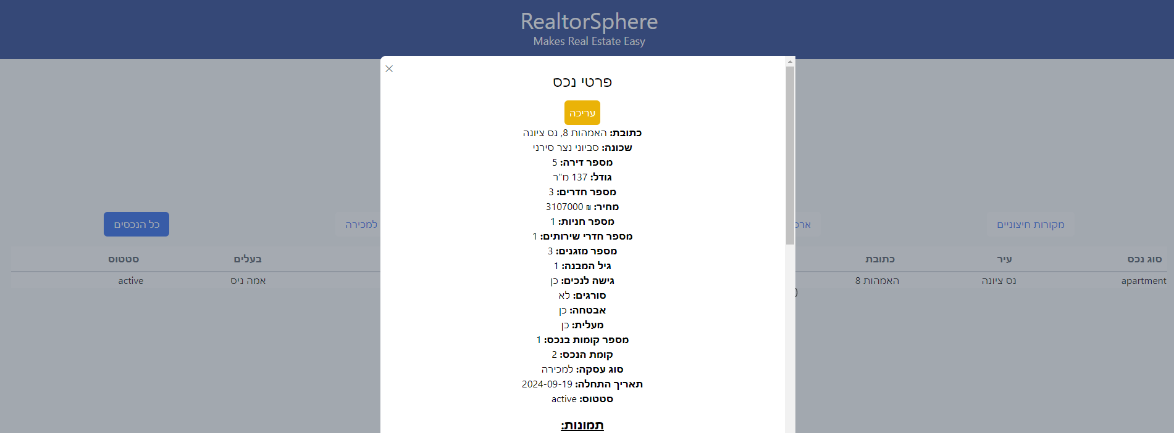  
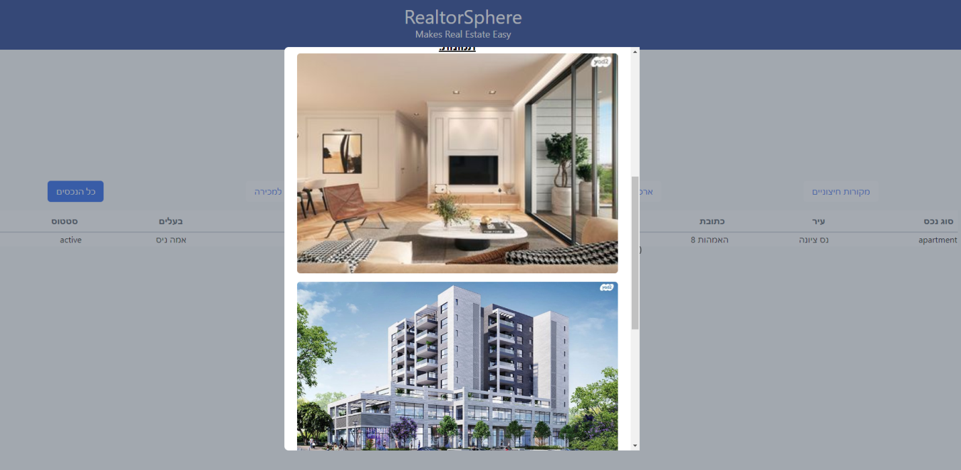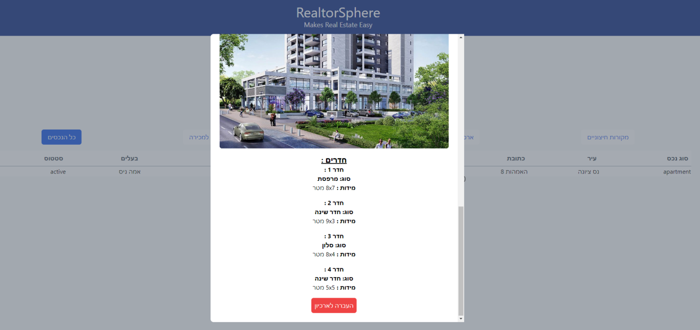  
1. לעריכת הנכס יש ללחוץ על "עריכה" למעלה.   
2. להעברת הנכס לארכיון יש ללחוץ על "העברה לארכיון" למטה.   
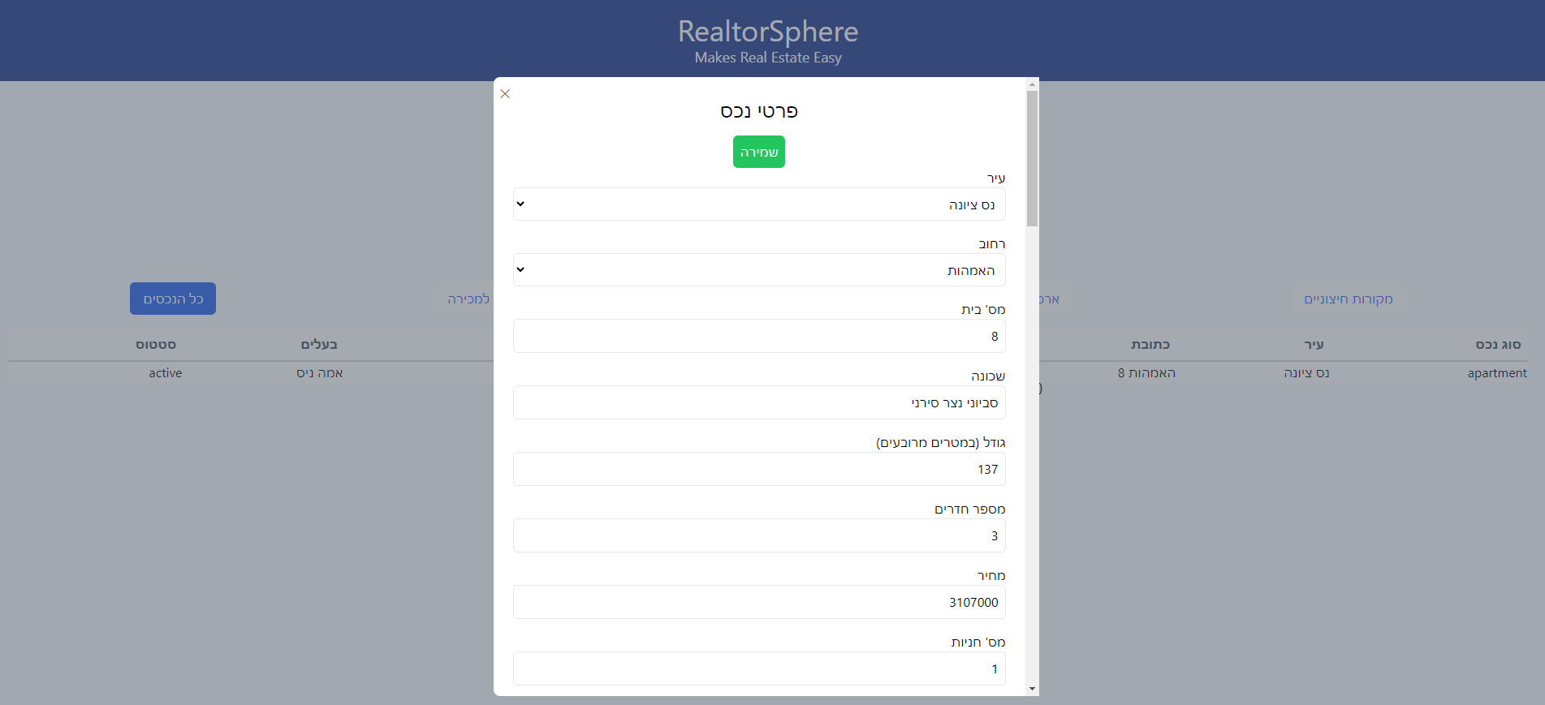  
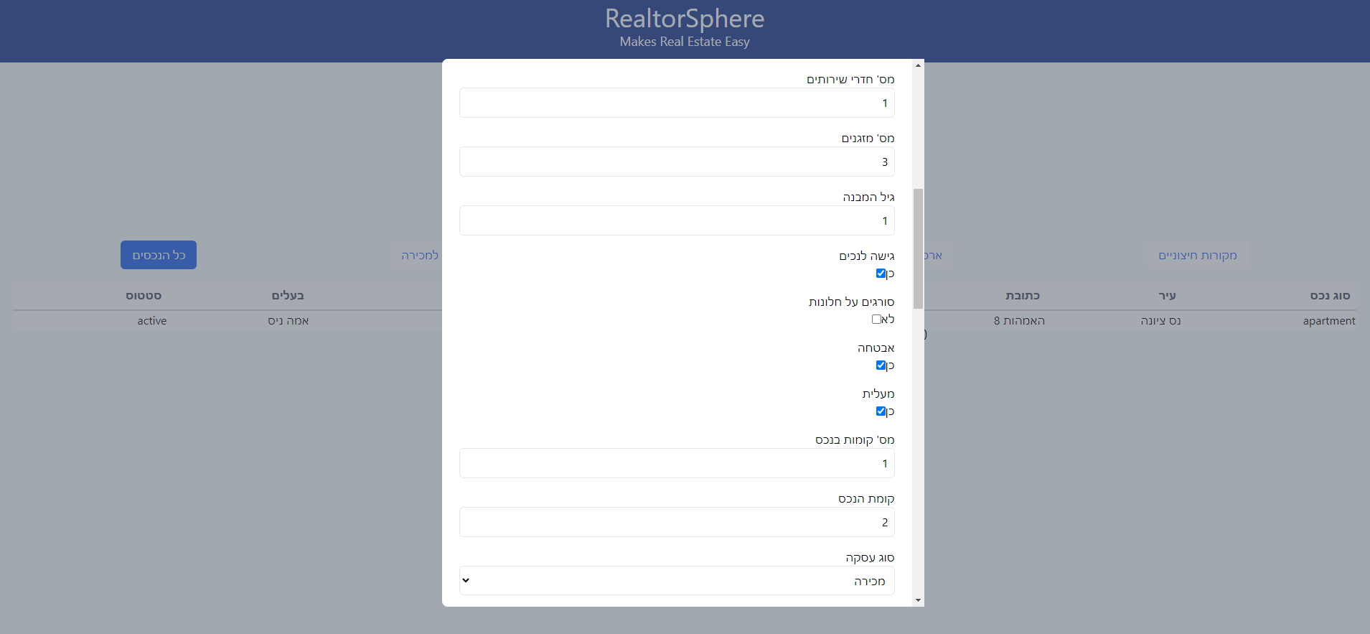  
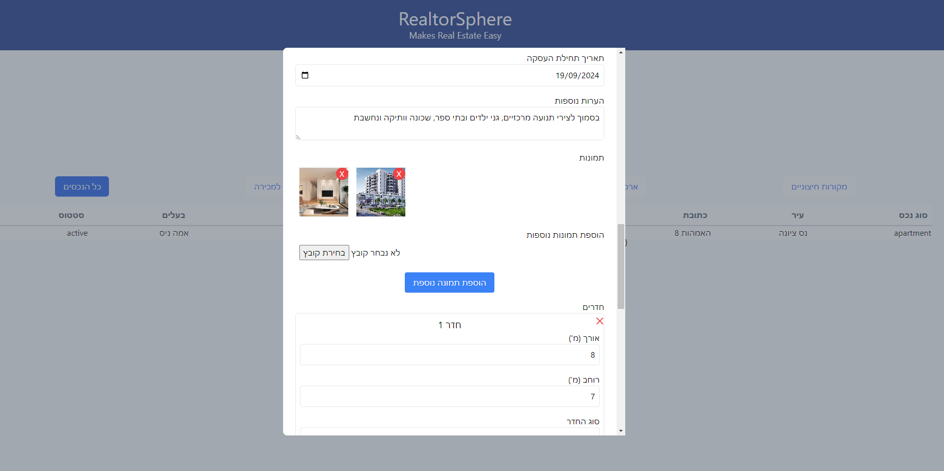  
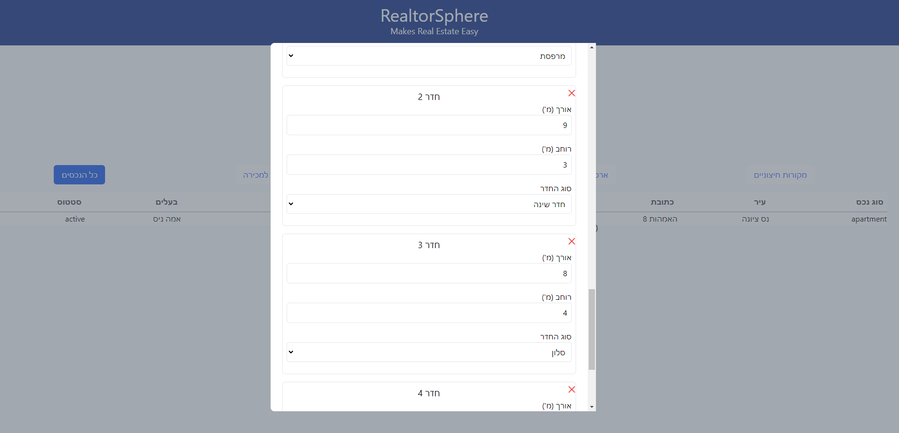  
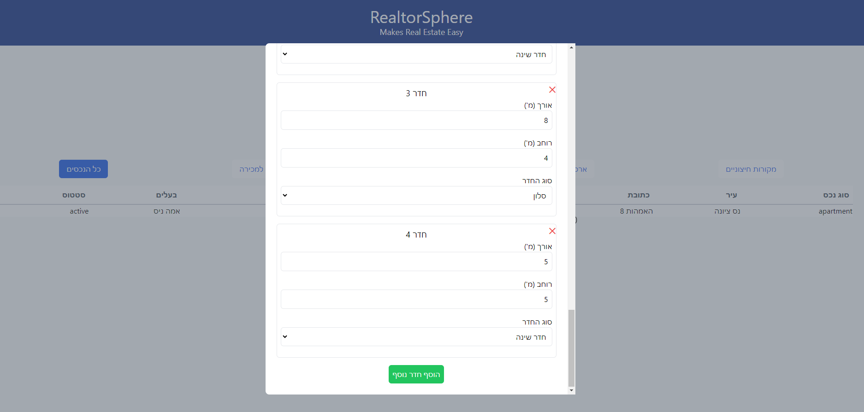  
בעריכה:  
1. עדכן את השדות אותם תרצה לעדכן.  
2. למחיקת תמונה, לחץ על האיקס בפינת התמונה.   
3. למחיקת חדר לחץ על האיקס בפינת שדה החדר.   
4. לשמירה לחץ "שמירה"   
5. לביטול לחץ על האיקס בפינה השמלית העליונה של החלון.   
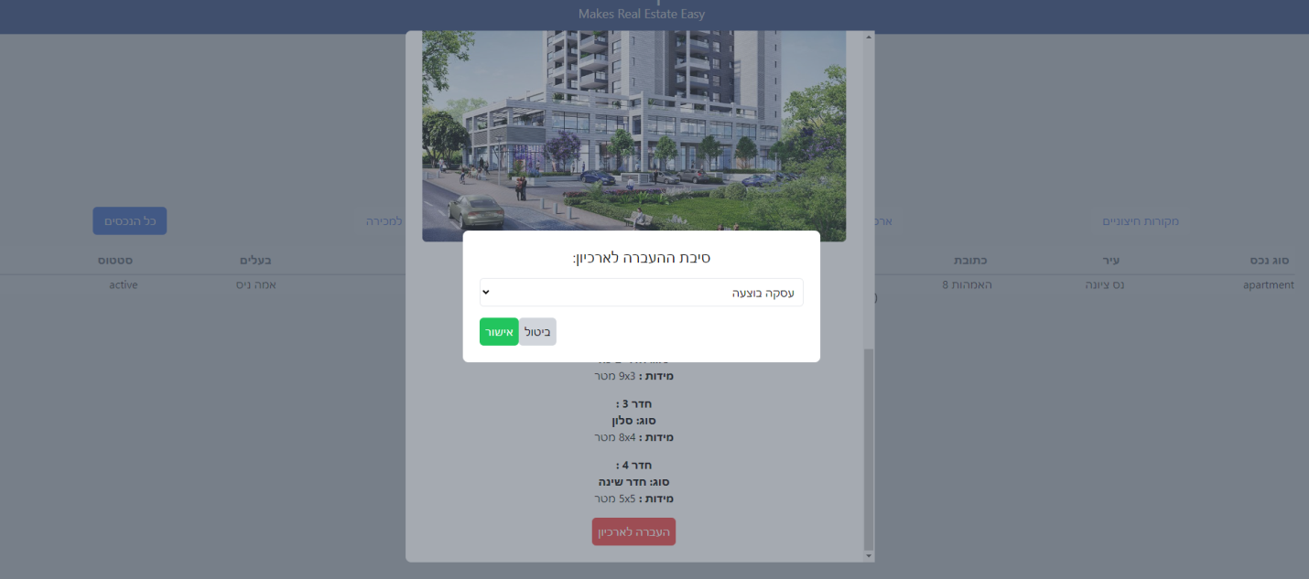  
העברה לארכיון:   
1. בחר סיבת העברה לארכיון.  
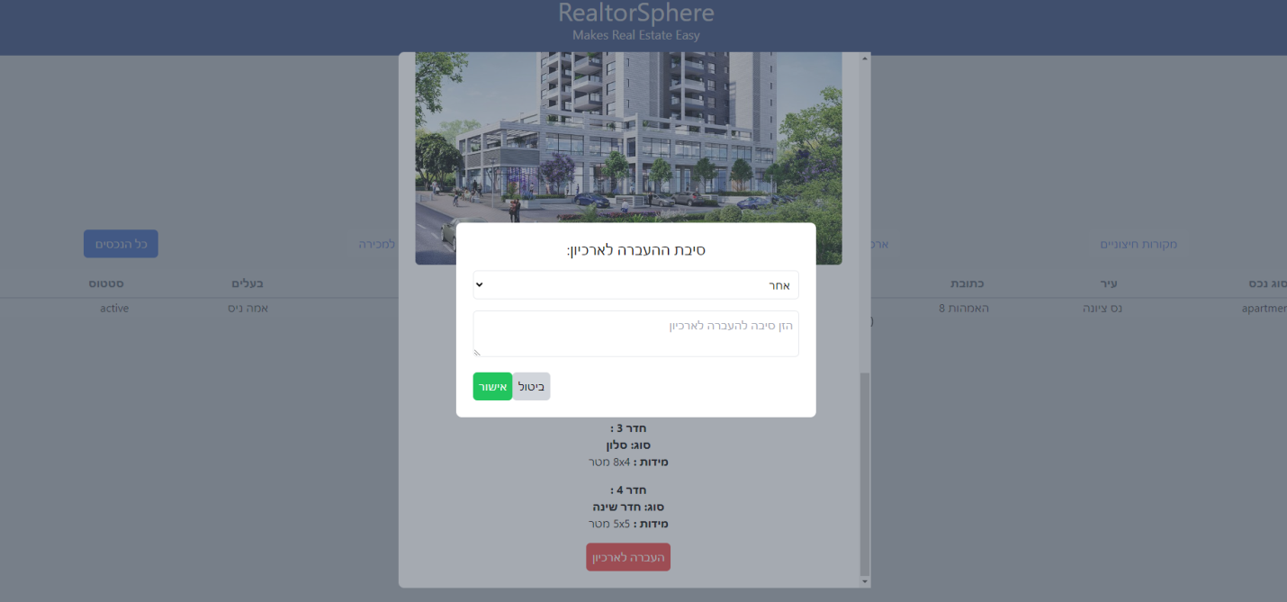  
2. אם הסיבה היא אחר, רשום את סיבת הארכוב.   
3. לשמירה לחץ "אישור".  
4. לביטול לחץ "בטל"  
ניהול לקוחות:

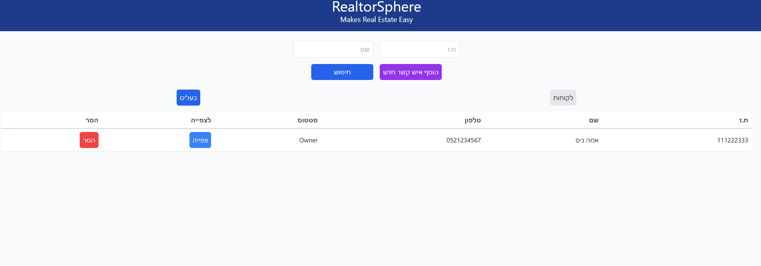

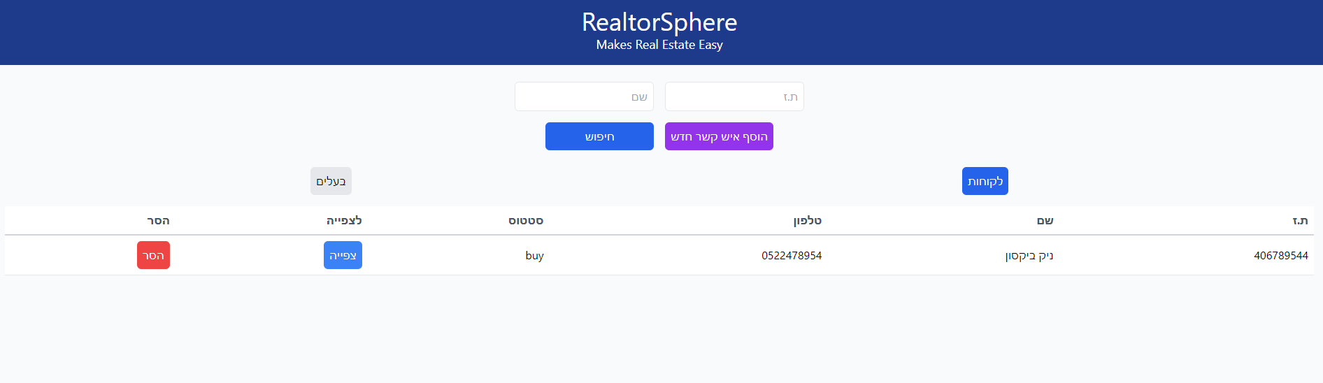  
1.לצפיה בבעלי דירות לחץ על "בעלים"  
2. לצפיה בלקוחות המחפשים נכס לחץ על "לקוחות"  
3. לחיפוש לקוח הקש את תעודת הזהות שלו בשדה החיפוש ו/או את שמו ולחץ על חיפוש.  
4. להוספת לקוח/בעלי נכס חדשים לחץ על "הוסף איש קשר חדש"   
5. להסרת לקוח/בעלי נכס לחץ על "הסר" בשורת הלקוח הרצוי להסרה.  
6. לצפיה ועריכת פרטי הלקוח לחץ על "צפייה" בשורת הלקוח הרצוי.

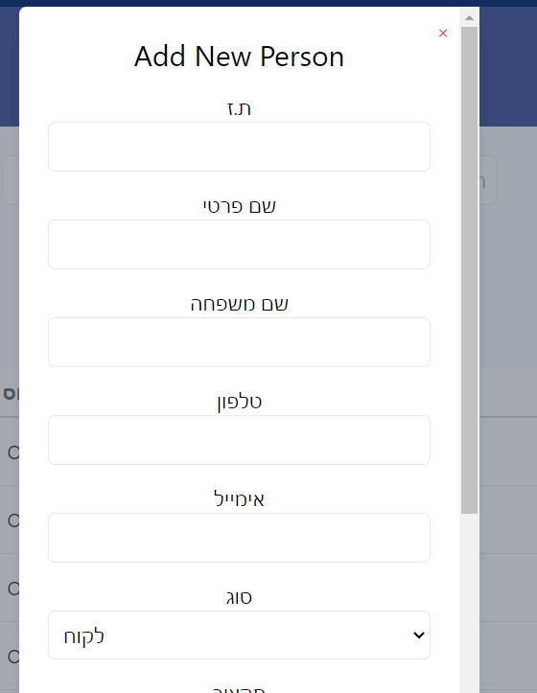  
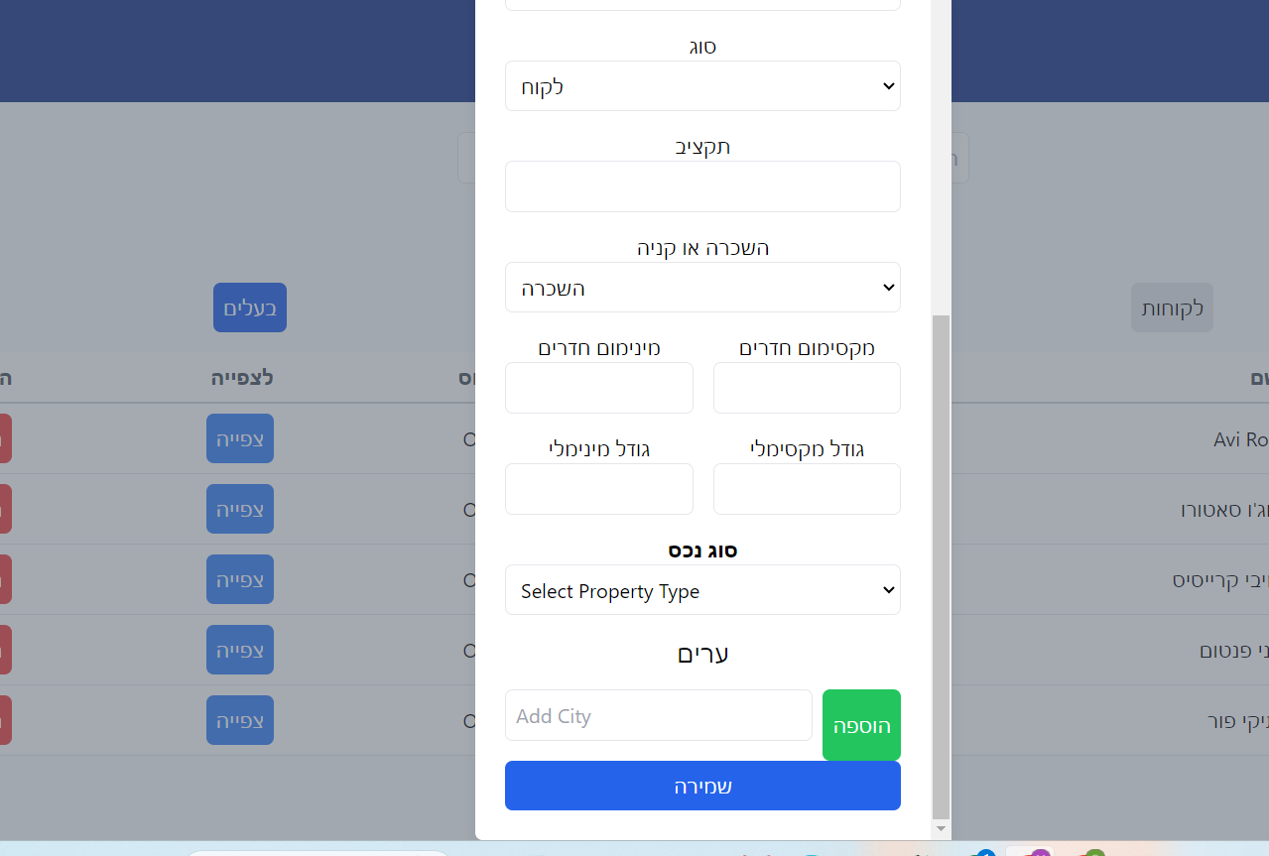  
הוספת איש קשר חדש:  
1. רשום את תעודת הזהות של איש הקשר.  
2. רשום את שם המשפחה של איש הקשר.   
3. רשום את מספר הטלפון של איש הקשר.  
4. רשום את האימייל של איש הקשר.   
5. בחר את סוג איש הקשר: לקוח או בעלים.   
6. עבור לקוח- רשום את תקציבו לנכס שהלקוח מחפש.  
7. בחר האם הלקוח מחפש לקנות או להשכיר נכס.   
8. רשום את טווח החדרים לנכס שהלקוח מחפש.  
9. רשום את טווח הגדלים לנכס שהלקוח מחפש.

10.בחר את סוג הנכס שהלקוח מעוניין בו.   
11. רשום מה העיר בה הלקוח מחפש נכס.   
12. אם הלקוח מחפש במספר ערים, לחץ על "הוספה" והוף ערים נוספות.  
13. אם ברצונך להסיר עיר מסויימת לחץ על "הסרה"

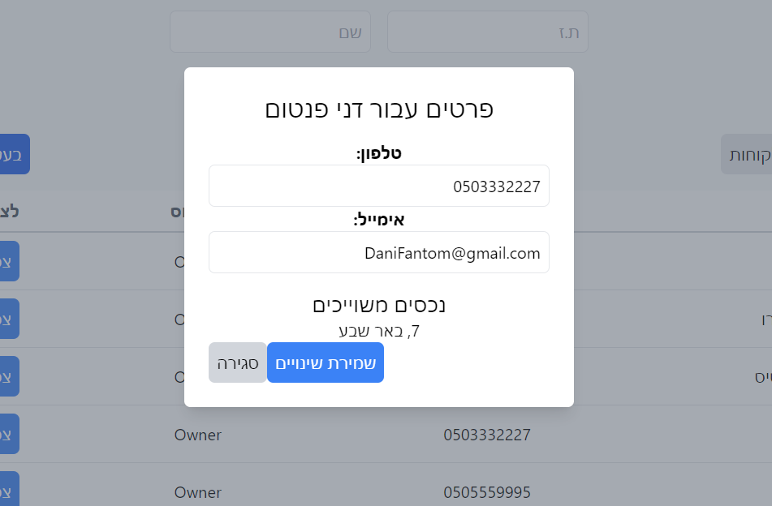  
בעריכת בעלי נכס:  
1. אם ברצונך לשנות את מספר הטלפון, רשום את מספר הטלפון לעדכון.   
2. אם ברצונך לשנות את האימייל, רשום את האימייל המעודכן.   
3. לשמירה לחץ על "שמירת שינויים".  
4. לביטול לחץ על "סגירה"   
  
בעריכת פרטי לקוח:   
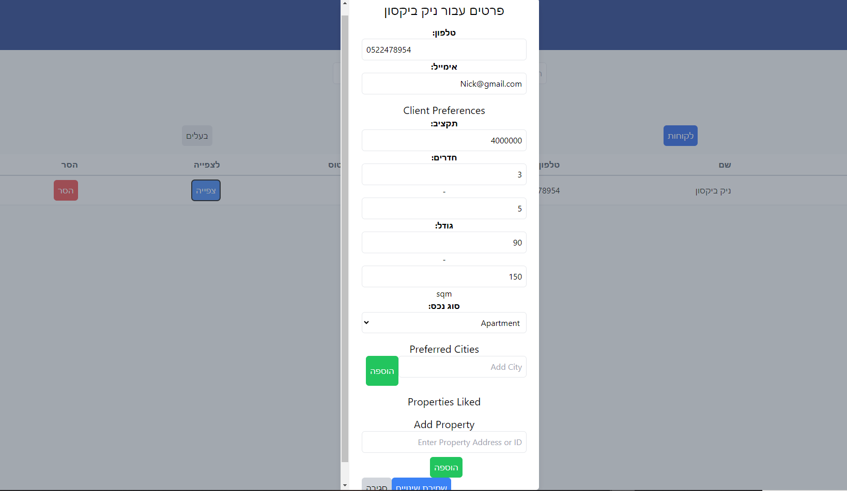  
1. עדכן את השדה אותו תרצה לשנות  
2. אם ברצונך להוסיף או להסיר ערים, לחץ על הוספה והסרה בהתאמה.

3.אם ברצונך להוסיף או להסיר נכסים שהלקוח מעוניין או לא מעוניין בהם לחץ על הוספה והסרה בהתאמה.

4.לשמירה לחץ על "שמירת נתונים".

5.לביטול/ סגירה לחץ "סגירה"

התאמה:

בדף זה מתווך יכול למצוא בעזרת האלגוריתם נכסים מותאמים ללקוחות שלו בהתאם להעדפות שלהם בצורה אוטומטית. האלגוריתם יכול לתת גם תוצאות לנכסים שנמצאים בארכיון, למקרה והמתווך יוסיף נכס דומה בעתיד.

על מנת להפעיל את האלגוריתם:

1. פתח את רשימת הלקוחות ובחר לקוח עבורו תרצה להתאים נכסים.
2. לחץ על "בצע התאמה"

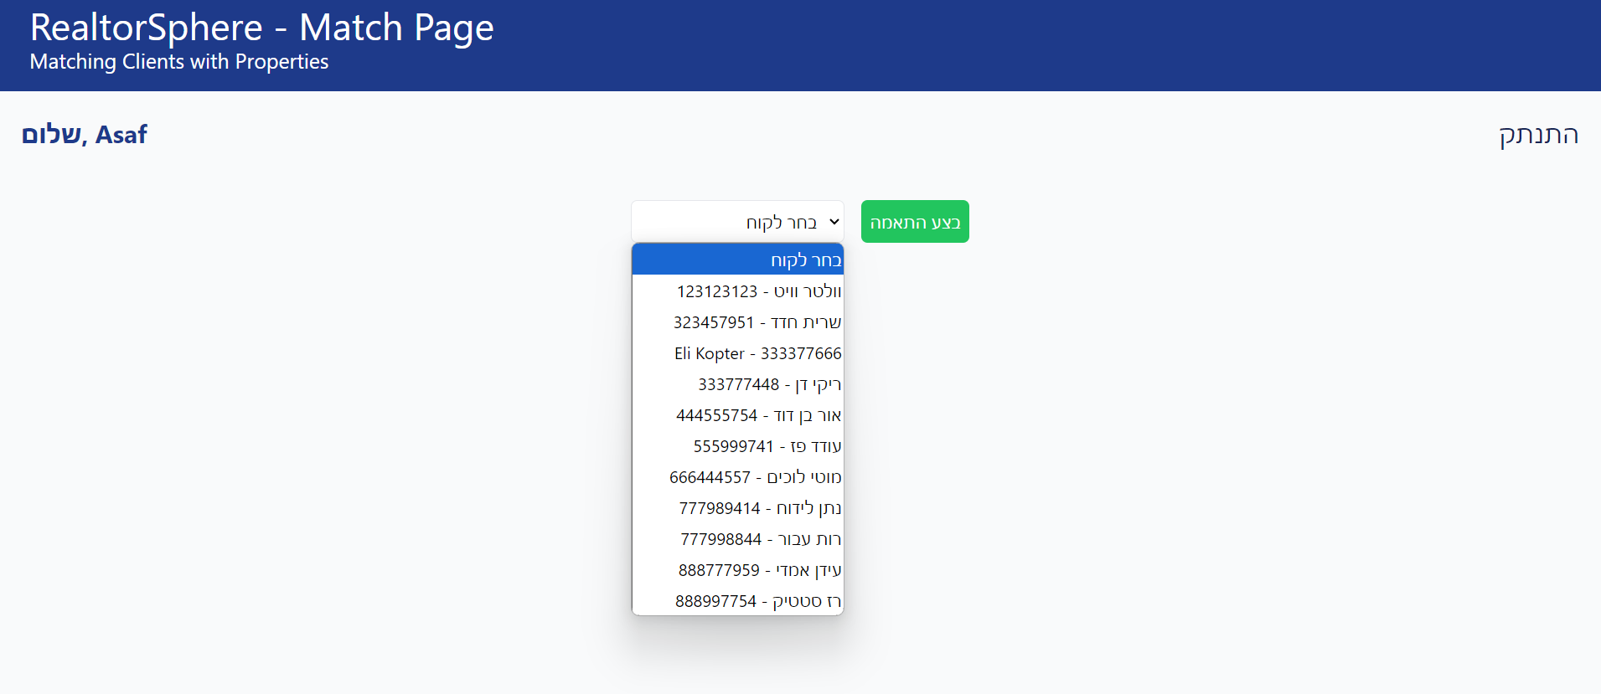

1. יופיע חלון עם רשימה של 3 נכסים מתאימים.
2. אם במערכת שלך אין מספיק נכסים להתאמה המערכת תתריע על כך.
3. אם יש נכס שתרצה להעביר את פרטיו ללקוח המיועד לחץ על "send info" מתחת לנכס הרצוי

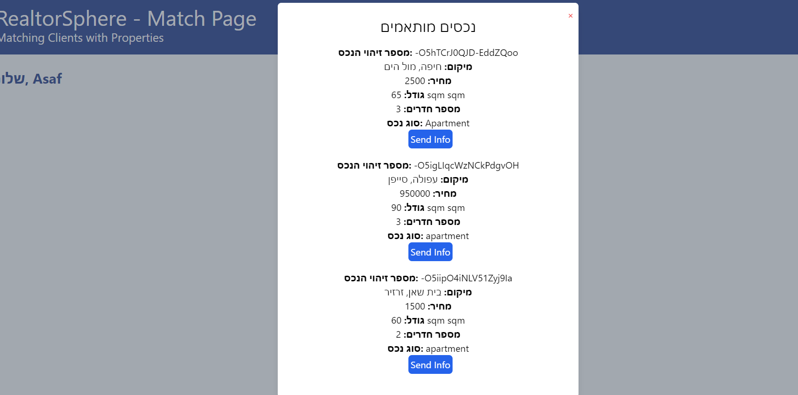

סיכומי פגישות:

בעמוד הזה המתווך יכול לעקוב אחר העסקאות שהוא מבצע עבור כל נכס. בעמוד זה יש טבלה עם כל העסקאות הקיימות פתוחות וסגורות. אפשר לפתוח, לצפות ולערוך עסקה. אפשר לסגור אותה ולהוסיף עסקה חדשה. אפשר גם השורת החיפוש לחפש עסקאות ספציפיות.

על מנת לסגור עסקה:

1. לוחצים על כפתור ה- "סגור" ליד העסקה הרצויה בטבלה.
2. עסקה שנסגרה כפתור ה"סגור" שלה הופך לטקסט.

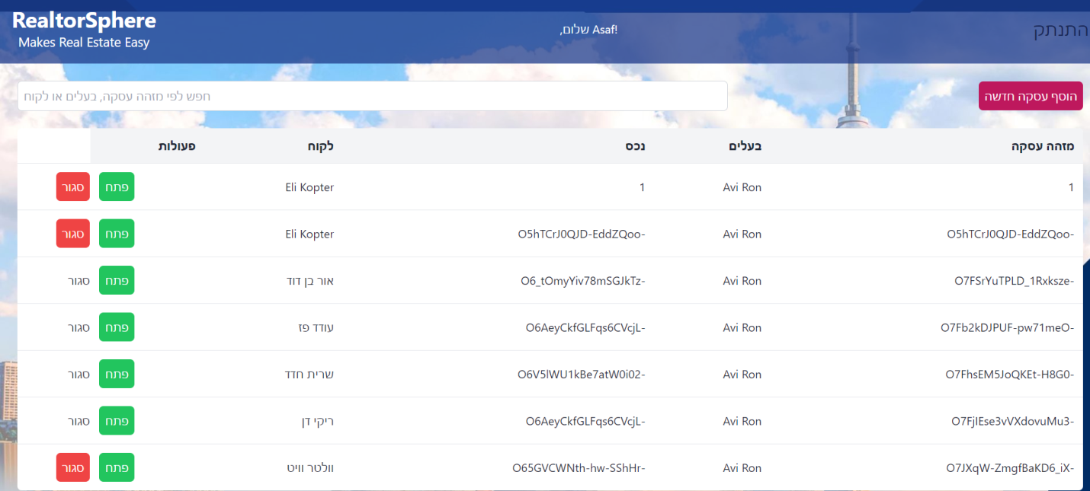

על מנת להוסיף עסקה חדשה:

1. לוחצים על הכפתור "הוסף עסקה חדשה" שבראש העמוד.
2. בוחרים את הלקוח המעוניין מהרשימה.
3. בוחרים בבעל הנכס של הנכס מהרשימה.
4. בוחרים בנכס מהרשימה.
5. בוחרים תאריך.
6. מכניסים מחיר ראשוני.
7. כותבים הערה אם יש.
8. לוחצים על " צור עסקה חדשה".

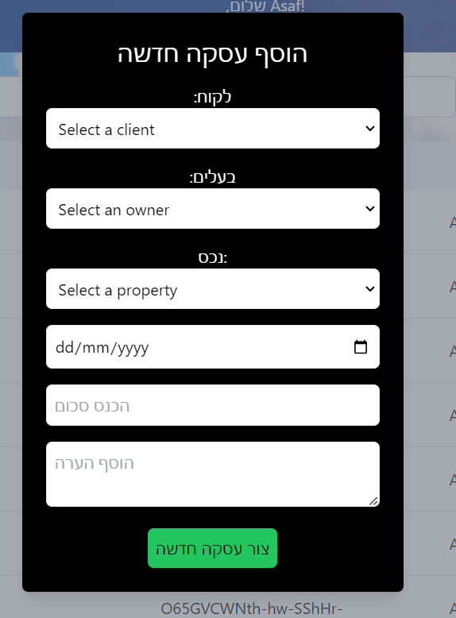

על מנת להוסיף מחיר חדש לעסקה:

1. לוחצים על "פתח" ליד הנכס הרצוי.
2. מכניסים מחיר חדש.
3. בוחריםאת מציע המחיר מרשימה.
4. מוסיפים הערה עם יש.
5. לוחצים על "הוסף מחיר" על מנת לשמור או "סגור" כדי לא לשמור.

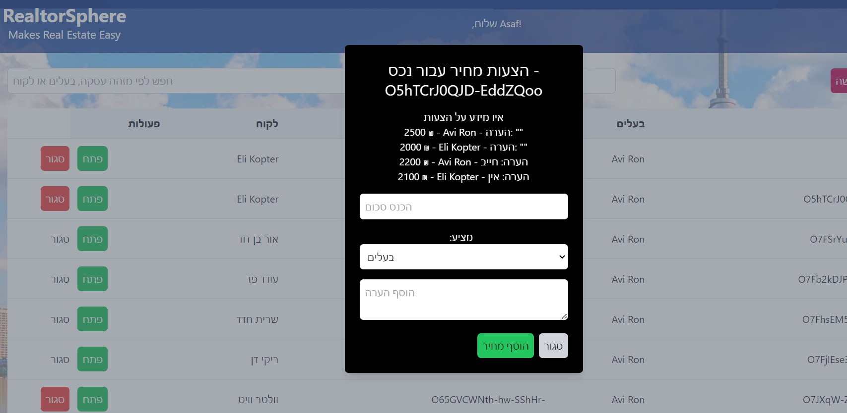  
דו"חות:  
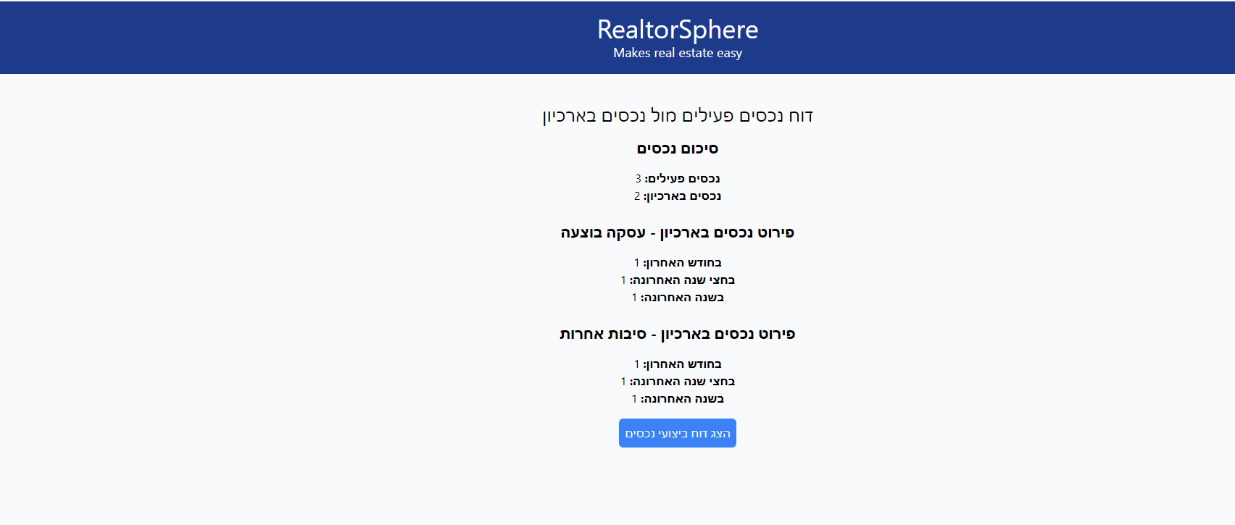

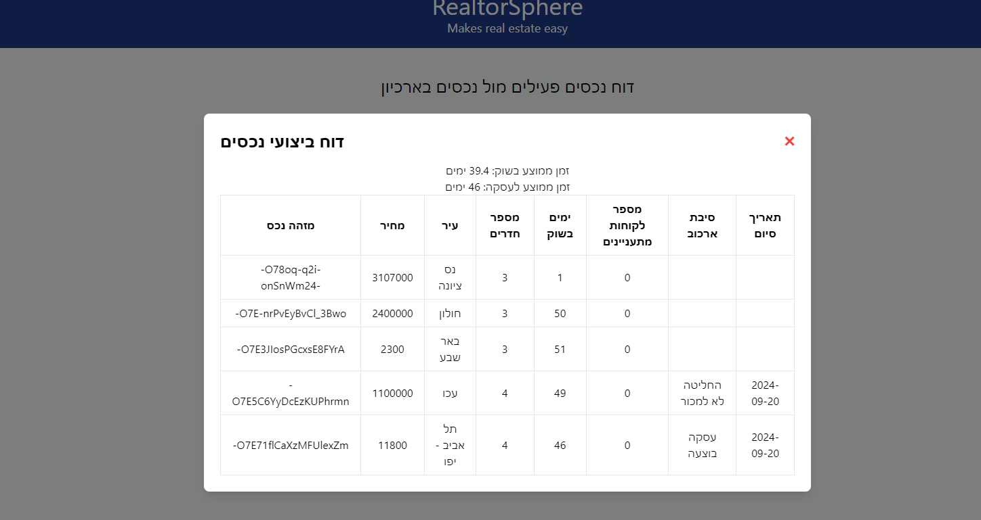  
לחץ על "הצג דוח ביצועי נכסים" על מנת לראות פרטים עבור כל נכס וזמן ממוצע עבור נכסייך בשוק וזמן ממוצע לעסקה.

**References:**

https://www.javatpoint.com/firebase-realtime-database - firebase

https://en.wikipedia.org/wiki/PyCharm - Pycharm

https://en.wikipedia.org/wiki/Flask_(web_framework) - flask

https://www.bairesdev.com/blog/what-is-flask/ - flask

https://kinsta.com/knowledgebase/what-is-github/ - GitHub

https://www.python.org/doc/essays/blurb/ - python

https://www.geeksforgeeks.org/send-mail-gmail-account-using-python/ - SMTP

https://geeksforgeeks.org/what-is-react/ - React

https://www.developer.com/languages/pycharm-review/ - Pycharm

https://kinsta.com/knowledgebase/what-is-github/ - Github

https://www.freecodecamp.org/news/what-is-html-definition-and-meaning/ - Html

https://www.w3schools.com/python/python_intro.asp - Python

https://developer.mozilla.org/en-US/docs/Web/JavaScript Javascript

https://www.w3schools.com/nodejs/nodejs_intro.asp - Nodejs

https://www.patterns.dev/react/ - React

https://www.geeksforgeeks.org/client-server-model/ - Server

https://en.wikipedia.org/wiki/API - API

https://www.atlassian.com/agile - Agile methodology

https://nadlanone.co.il/ - NadlanOne

https://bmby.co.il/ - Bmby

https://webtiv.co.il/welcome/ - Homely

https://blog.back4app.com/firebase-storage/ - Firebase storage

https://medium.com/@MinimalGhost/what-is-axios-js-and-why-should-i-care-7eb72b111dc0 - Axios

https://supertokens.com/blog/what-is-jwt - JWT

https://www.nvidia.com/en-eu/glossary/numpy/ - Numpy

https://blog.hubspot.com/website/what-is-tailwind-css - TailwindCSS

https://www.geeksforgeeks.org/cosine-similarity/ - Cosine similarity

https://www.geeksforgeeks.org/k-nearest-neighbours/ - KNN

<https://render.com/> - Render  
  
  
  
  
GitHub: <https://github.com/HannaKru/RealtorSphere>  
Website: https://realtorsphereapp.onrender.com/